Stephen J. Hotard

July 20, 1949 – April 7, 2018

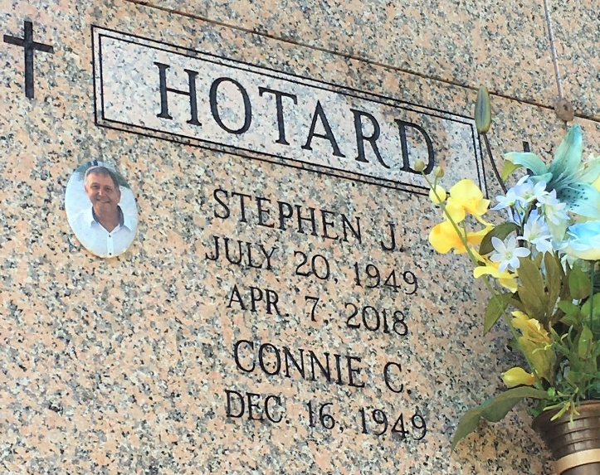

Photo by Team T-Lo

Stephen J. Hotard passed away on Saturday, April 7, 2018 at the age of 68. He was born in New Orleans, LA and was a resident of LaPlace, LA. He is survived by his wife of 41 years, Connie Cadow Hotard and his three sons: Heath Hotard (Rachel), Chad Ryan (Jenn) and Jared Hotard (Tania Tabor). Stephen loved to spend time with his five grandchildren: Hannah, Emily, Michael, Cooper and Olivia. He is also survived by his three siblings: Albert ‘Nootsie’ Hotard (Kathy), Louis ‘Bird’ Hotard and Carolyn Hotard Weber. He was the son of the late Albert and Marie Stein Hotard. Stephen will be missed by his extended family of brothers-in-law, sisters-in-law and many nieces and nephews. He was well-loved and respected and would do anything for his family. A special note of appreciation to the staff of Notre Dame Hospice for their care and compassion in his final days.   
 Relatives and friends are invited to attend the Memorial Mass at St. Joan of Arc Catholic Church, 529 W. 5th Street, LaPlace, LA on Thursday, April 12, 2018 at 11:30 a.m. Visitation at the church from 9:30 a.m. until 11:30 a.m. Inurnment in St. Peter Cemetery.

Millet-Guidry Funeral Home, LaPlace, Louisiana

April 10, 2018