Anna Lee (Jones) Howard
July 25, 1928 – September 11, 2008

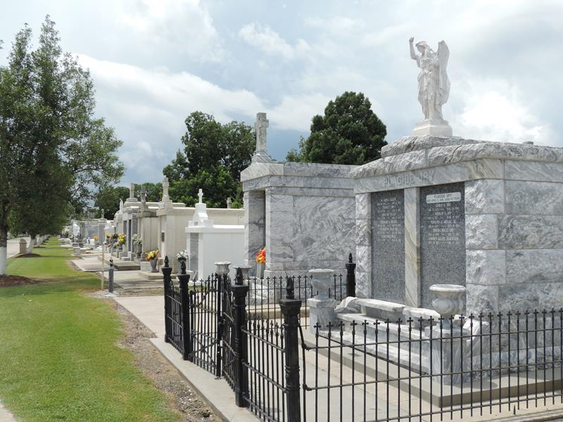
Photo by Team T-Lo

Anna Lee Jones Howard was called to her eternal home on September 11, 2008 after a courageous battle to overcome the effects of a massive stroke.
She was born in Montz, Louisiana on July 25, 1928 to Jesse Eual Jones and Anna Duhon Jones. She was a beloved daughter, sister, wife, mother, grandmother and great- grandmother. She was a devoted member of St. Joan of Arc Church as well as a teacher at St. Joan of Arc School for 40 years. She was loved by all who knew her and whose lives she touched. Her talents were as limitless as her love of life and family. One of her greatest pleasures was quilting heirlooms for her grandchildren. She was a talented seamstress and took great pride in sewing special occasion dresses and gowns for her granddaughters.
She was preceded in death by her parents, her husband James E. Howard, her eldest son John E. Howard and a sister Mary Alice Guidry.
She is survived by her daughter Susan Zeringue and husband Leon, sons James (Buzz) Howard and wife Carolyn, David Howard and wife Marsha, and Mark Howard, grandchildren Jason Zeringue and wife Erin, Jonathan Zeringue and wife Laurie, Alison Howard and husband Mike, Christopher, Amanda, Courtney, Abby, Katie, John and Brittany Howard, great-grand- children Alyssa Frederick, Coleman and Camille Zeringue, sisters Enid Duhe and Jewel Breaux and husband Claud and numerous nieces and nephews.
Relatives and friends are invited to attend services. Visitation at St. Joan of Arc Catholic Church, 529 W. 5th Street, Laplace, La., on Monday, September 15, 2008 from 10:00AM to 12:00Noon. Followed by Religious Service at 12:00Noon. Burial in St. Peter Cemetery Reserve, La.
In lieu of flowers, please make contributions to the Monsignor Vincent Endowment Fund, providing scholarship assistance to qualifying students to attend St. Joan of Arc Catholic School. Contributions may be mailed to 412 Fir Street, LaPlace, La. 70068. Arrangements by Millet-Guidry Funeral Home LaPlace, La.
Times Picayune, New Orleans, Louisiana
September 13, 2008

