Laura Marie (Boe) Hutchinson

September 5, 1933 – February 4, 2010

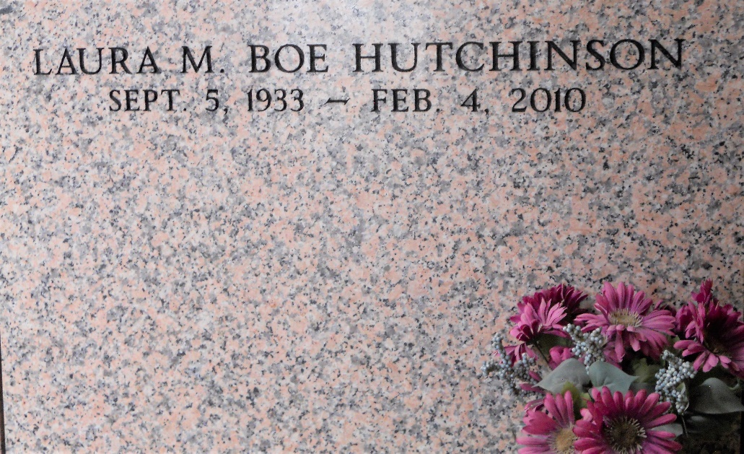

Photo by Team T-Lo

Laura Boe' Hutchinson passed away on Thursday February 4, 2010.

Beloved mother of Curtis, Danny, E. J., Jeff and Robert Hutchinson and Brenda H. Lee. Also survived by loving Grandchildren and Great-grand-children. Sister of O'Neil, John and Leonard Boe, Rita Bonadona and the late Jim Boe, Hilda Crumpton and Amelia Laiche. Age 76. A native of Reserve, La. and a resident of Walker, La.

Relatives and friends are invited to attend services. Visitation at Millet-Guidry Funeral Home, 2806 W. Airline Hwy. LaPlace, La. on Monday, February 8, 2010 from 5:00 pm to 9:00 pm and on Tuesday from 11:00 am to 1:00 pm. Followed by Religious Services in the funeral home chapel at 1:00 pm. Burial in St. Peter Cemetery, Reserve, La.

Times Picayune, New Orleans, Louisiana

February 7, 2010