Rosalind (Millet) Hutson

January 14, 1949 – March 10, 2019

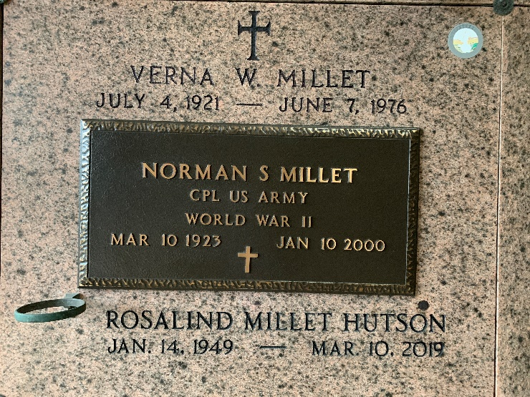

Photo by Team T-Lo

Rosalind Millet Hutson of LaPlace, Louisiana passed away on March 10, 2019 at the age of 70 years old, surrounded by her family.

She is survived by her husband of 16 years, Jerry Hutson. Rosalind was the daughter of the late Norman Samuel Millet, Sr. and the late Verna Weber Millet. Rosalind was the beloved sister of Norman S. Millet, Jr. (Carol), Brenda Millet, Brad Millet (Debbie), Jan Millet Chiquet, and Melanie Millet Moreau. Rosalind was the mother of Scott Damron (Kelly), Edward Damron, and Theodore Damron. Rosalind was the stepmother to Clifton Joullian (Barry), Kelly Viator (Kyle), and Lisa Savoy (Mike). She had 14 grandchildren, and 2 great grandchildren. Rosalind is survived by numerous nieces and nephews.

During her wonderful life, Rosalind enjoyed gardening, cooking, reading, lunches with her close friends, and “her Saints” football on Sundays. She will be dearly missed by all.

Relatives and friends are invited to attend a visitation on March 14, 2019 beginning at 10:00 am, followed by a Christian Funeral Mass at 12:00 pm at St. Joan of Arc Catholic Church at 529 West 5th Street, LaPlace, LA. Arrangements by Millet-Guidry Funeral Home, 2806 West Airline Hwy, LaPlace, LA. Interment will be at St. Peter’s Cemetery in Reserve, LA at a later date.

Millet-Guidry Funeral Home, LaPlace, Louisiana

March 12, 2019