Albin Joseph Hymel
July 27, 1917 – September 22, 2006

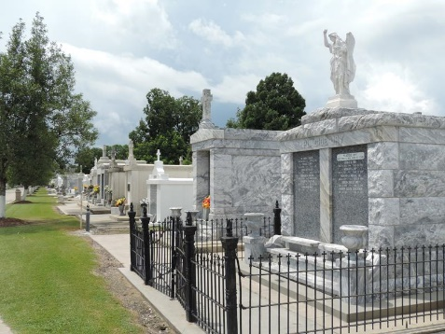

Albin Joseph HYMEL, beloved husband of 67 years of Anne FALGOUST HYMEL, died Friday, September 22, 2006 at 12:40 P.M. at his home at the age of 89.
Along with his wife, he is survived by his daughters, Julie H. BRADY, Linda H. BRADY and Rosalind H. ROUSSELLE, daughter-in-law, Beatrice R. HYMEL, and sons-in-law, Jimmy BRADY and Teddy BRADY. He leaves behind grandchildren, Robin M. HYMEL, Ann B. CLEMENT, Sue M. HYMEL, James R. BRADY, Jr., Hope H. SNOWDY, Celeste H. TOUPS, Jeffrey P. BRADY, Christie B. GUILLORY, Erin B. St. PIERRE, Amy R. RONNENBURG, Donna B. MOYE, Stephen J. BRADY, Mark A. BRADY, Adam S. ROUSSELLE, and Abby R. BAKER. He also leaves behind 20 great-grandchildren. He is also survived by his sister, Rose H. TROSCLAIR, and brothers, Arnold HYMEL and Clement HYMEL.
He was preceded in death by his parents, Etienne Clement HYMEL and Regina SONGY HYMEL; his son, Timothy M. HYMEL, an infant daughter, Sharlene Mary HYMEL, one grandchild, Melanie Claire BRADY, his sister, Blandine H. WILLIAMS, and his brother, Gerard HYMEL.
Mr. HYMEL was a native of St. James, LA and a resident of Reserve, LA for over 72 years. He was a retired foreman at the Godchaux Sugar Refinery in Reserve and a parishioner of St. Peter Catholic Church in Reserve.
Relatives and friends of the family are invited to attend services on Monday, September 25, 2006 with visitation at Millet-Guidry Funeral Home, 2806 West Airline Highway, LaPlace, LA from 9:00 A. M until 11:30 A. M., followed by Religious Services at St. Peter Catholic Church, Reserve, LA at 12:00 noon, with burial in St. Peter Church Cemetery.

Times-Picayune, New Orleans, Louisiana
September 24, 2006

