Anne Madeleine-Sophie (Falgoust) Hymel
September 9, 1915 – September 26, 2014

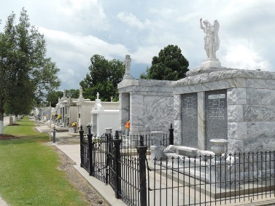

Anne Madeleine-Sophie Falgoust Hymel died on Friday September 26, 2014 at her home at the age of 99. She was preceeded in death by her beloved husband of 67 years, Albin Joseph Hymel.
She is survived by her daughters, Julie H. Brady and her husband Jimmy, Linda H. Brady and her husband Teddy, and Rosalind H. Rousselle and her fiancé David Clement. She leaves behind grandchildren, Robin M. Hymel, Ann B. Clement, Sue M. Hymel, James R. Brady, Jr., Hope H. Snowdy, Celeste H. Toups, Jeffrey P. Brady, Christie B. Guillory, Erin B. St. Pierre, Amy R. Ronnenburg, Donna B. Moye, Stephen J. Brady, Mark A Brady, Adam S. Rousselle and Abby R. Baker. She also leaves behind 27 great-grandchildren. Anne is also survived by her sister, Edith Falgoust Hepler.
She was also preceded in death by her parents, Sophie Amedee Falgoust and Louis Hermogene Falgoust; her son, Timothy M. Hymel and daughter-in-law, Beatrice R. Hymel, an infant daughter, Sharline Mary Hymel, one grandchild, Melanie Claire Brady and her brothers Louis, Eddy, Stanley, Willis and John Falgoust and sisters, Stephanie, Mary and Claire Falgoust.
Mrs. Hymel was a native of Vacherie, LA and a resident of Reserve, LA for over 90 years. She was a homemaker and a parishioner of St. Peter Catholic Church in Reserve. Her family wishes to give special thanks to all the staff of St. Catherine's Hospice and to her caregivers, Gloria Alexander, Angela Anderson and Neyuka Ceaser.
Relatives and friends are invited to attend services. Visitation at Millet-Guidry Funeral Home, 2806 W. Airline Hwy., LaPlace, LA on Monday September 29, 2014 from 9:00 A.M. to 10:45 A.M., followed by Mass at St. Peter Catholic Church, Reserve, LA at 11:00 A.M. Burial in St. Peter Cemetery Reserve, LA.

The New Orleans Advocate, Louisiana
Sep. 27 to Sep. 29, 2014

