Beatrice (Remondet) Hymel

March 22, 1934 – February 8, 2014

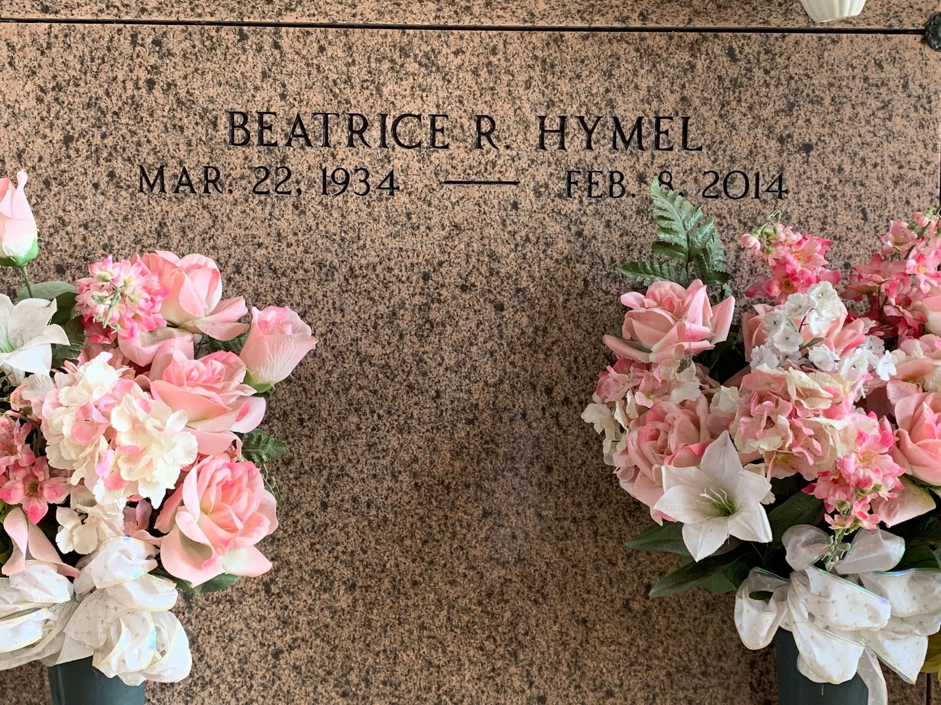

Photo by Team T-Lo

Beatrice Remondet Hymel died on Saturday February 8, 2014.

Beloved wife of the late Timothy Hymel. Mother of Robin Hymel, Suzanne Hymel, Hope H. Snowdy (Sterling) and Celeste H. Toups (Herman III). Grandmother of Lauren and Jordan Snowdy and Ashley and Jenna Toups. Daughter of the late Denis and Ida Remondet. Sister of Cleven Remondet Sr., and the late Eloi Remondet, Lorina Poche, Oleida Poche, Aurelia Remondet, Eugenie Remondet and Naomi Roussel. Age 79. A native and resident of Reserve, LA.

Relatives and friends are invited to attend services. Visitation at St. Peter Catholic Church, Reserve, LA on Tuesday February 11, 2014 from 10:00 am to 12:30 pm, followed by Mass at 1:00 pm. Burial in St. Peter Cemetery. Arrangements by Millet-Guidry Funeral Home, LaPlace, LA.

The New Orleans Advocate, Louisiana

Feb. 9 to Feb. 10, 2014