Etienne J. Hymel

July 4, 1916 – June 2, 1965

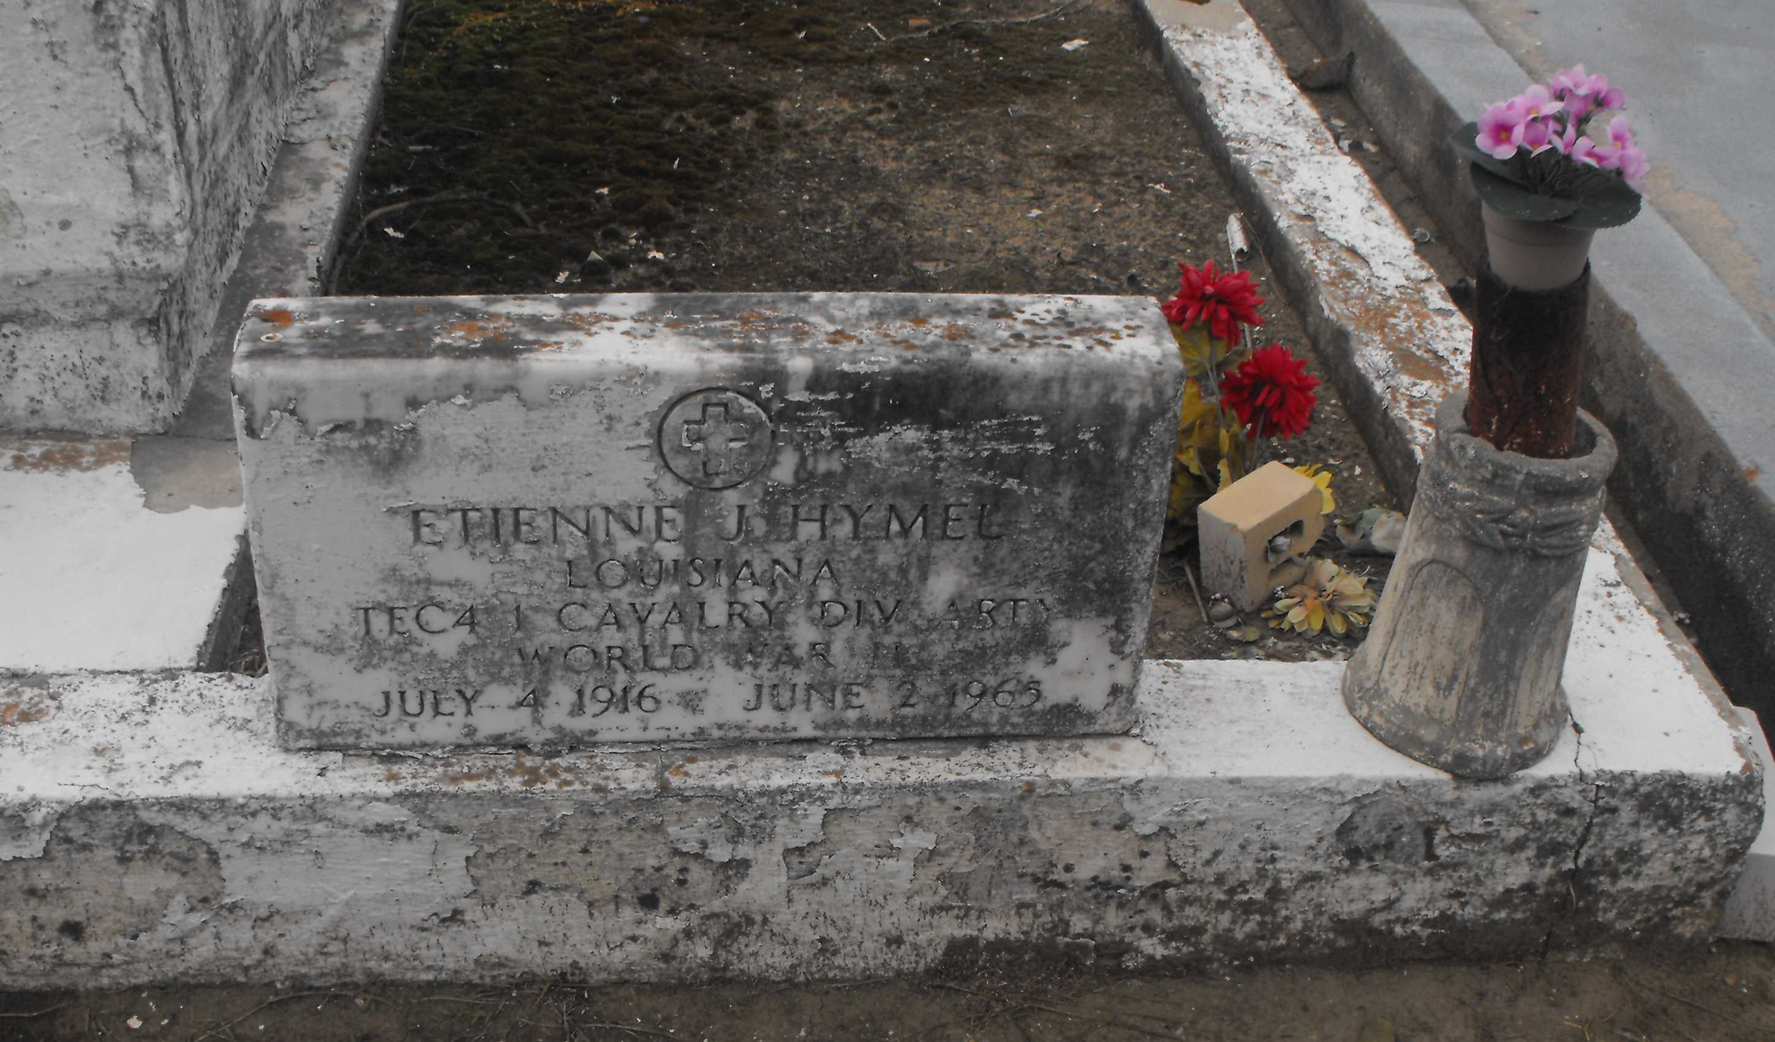

Photo by Mary Agnes Hammett

Etienne (Bud) Hymel, a native and resident of Laplace, Louisiana, died Wednesday 2 Jun 1865 at 10:25 a.m. at age 48 years.

He was the husband of Lillie Keating and the father of Mrs. Kelly Ray Jones of Baton Rouge, Prestley Ray Hymel of Doyle, Louisiana, Nancy Hymel, and stepfather of Sandra Spencer, both of Laplace. He was the son of the late Thomassin Hymel and Bertha Madere and the brother of Odette, Jules, Mrs. Peter Brady, Mrs. Richard Madere and Mrs. Hilda Nunn, all of Laplace, Mrs. Edmond Bourgeois of Lutcher, Louisiana, Mrs. Frank Dufresne of Norco, Louisiana, Mrs. Herbert Breaud of Metairie, Louisiana, and Mrs. George Kleinschmidt of New Orleans, and the late Lionel and Paul Hymel. Also survived by one grandchild.

Services were Friday 4 Jun 1965 at St Joan of Arc Church, Laplace, with interment in St Peter Cemetery, Reserve, Louisiana.

The Times-Picayune, New Orleans, Louisiana

3 Jun 1965