Glenn M. Hymel
December 7, 1946 – February 7, 2025

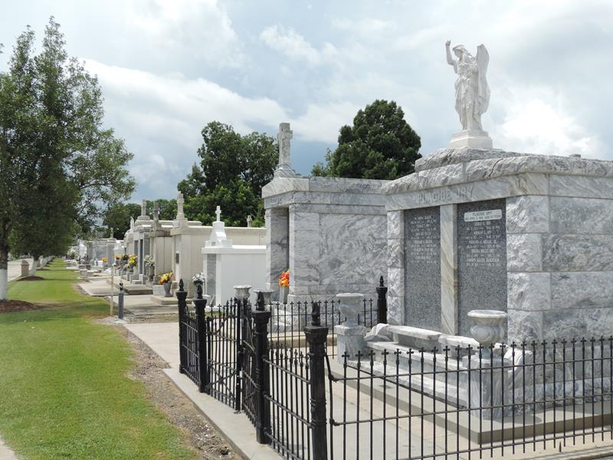
Photo by Mary Agnes Hammett

Dr. Glenn M. Hymel, a beloved father, grandfather, and professor, passed into eternity on February 7, 2025 at the age of 78.
He was born on December 7, 1946 to Rose Mae Triche Hymel and Clement Etienne Hymel in New Orleans, LA. His siblings are Debra DiLeo and Angel Songy. In 1965, Glenn met Linda, and they were blessed with two sons (Steven and Michael), two daughters (Judy and Donna), and eight grand- children (Sean, Jason, Andrew, Lilli, Luke, Jessica, Daniel, and Sarah). Glenn was also blessed with a cherished friend of many years, Loretta Orlando.
Glenn was a graduate of St. Aloysius High School. He earned an undergraduate degree at Loyola University and graduate degrees at the University of New Orleans. He served in a reserve unit of the U.S. Coast Guard from 1968-1974 and enjoyed a long and distinguished career of 49 years on the faculty at Loyola University.
Glenn lived a life marked by exceptional achievements. His unwavering faith provided him the courage to face life's challenges with strength, grace, and resilience. He was compassionate and selfless, always placing the needs of others above his own. His family will forever remember and cherish the gift of his boundless love and devotion.
Services will be held on Friday, February 14, 2025 at St. Benilde Church, 1901 Division St., Metairie, LA, with visitation from 10:00-12:00 and a requiem Mass at 12:00. A burial will follow at St. Peter Catholic Cemetery,1550 Hwy 44, Reserve, LA. In lieu of flowers, donations in Glenn's memory may be made to St. Benilde Parish and Brother Martin High School.
Millet-Guidry Funeral Home, LaPlace, Louisiana

