Lydia (Plaisance) Hymel

March 27, 1904 – April 21, 1999

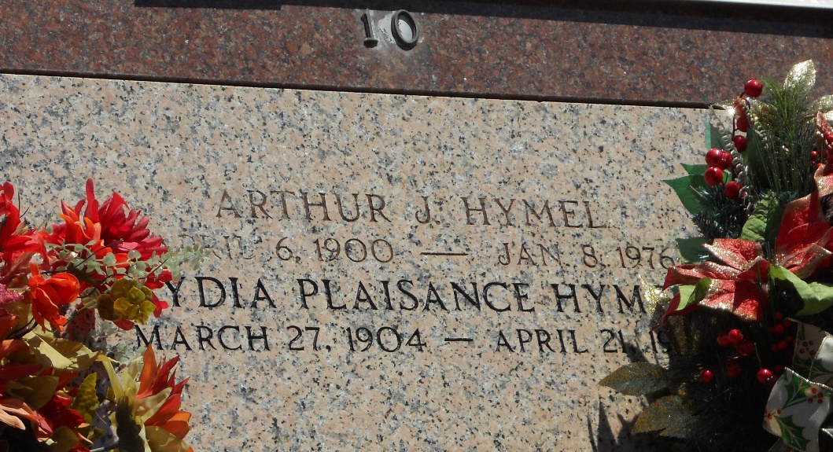

Photo by Team T-Lo

Lydia Plaisance Hymel, 95, a native of Belle Rose and resident of Garyville for the past 80 years, died April 21, 1999.  
 She was the wife of the late Arthur Hymel and the mother of Clyde, Kermit, Robert, Kenneth, Timothy and Michael Hymel, Gertrude Jacob, Betty Ramagos, Hazel Michel, Elmire Vicknair, Veronica Aucoin, Cynthia Shaubhut and Linda Haydel.  
 She was the daughter of the late Thomas and Aurelia Romero Plaisance and sister of the late Albert, Anthony and Samuel Plaisance, Alida Frederic, Ida Solar and Inez Grobe.  
 She is survived by 53 grandchildren, 115 great-grandchildren and 19 great-great-grandchildren.  
 Services were April 23, 1999 at St. Hubert Catholic Church, Garyville, with interment at St. Peter Cemetery, Reserve.

Unknown source