Ray Antoine Hymel Sr.
December 15, 1931 – December 4, 2014

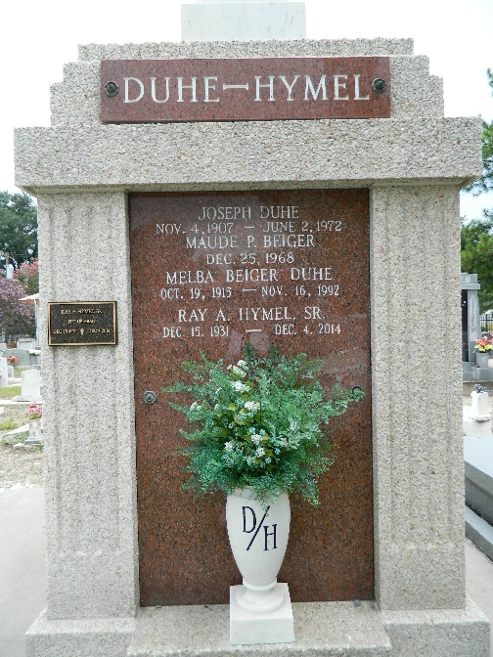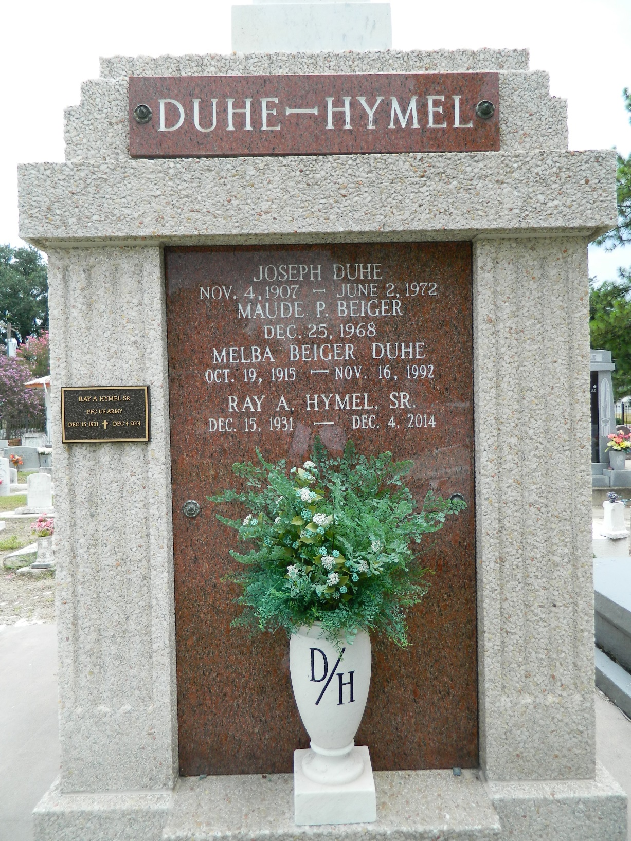

Ray Antoine Hymel Sr. died peacefully on Thursday, Dec. 4, 2014, at Chateau de Notre Dame in New Orleans. Hymel was born on Dec. 15, 1931, in Edgard, the eighth child of Numa Joseph Hymel Sr. and Marie Louise Schexnayder Hymel. He was the beloved husband of 59 years of Melba Duhe Hymel; father of Susan Hymel Mongrue, Reverend Ray A. Hymel and Steven J. Hymel; father-in-law of David M. Mongrue and Lauren Sprinkle Hymel; grandfather of Lauren, Andrew and Ashley Mongrue, and Christian, Veronica and Elijah Hymel; brother of Sister Mary Osanna Hymel, OP, and the late Ruth H. Kliebert, Maizie H. Jacob, Daniel G. Hymel Sr., Estelle H. Duhe, Numa J. Hymel Jr., Louise H. Remondet and Shirley Hymel; and brother-in-law of Edwina D. Hymel, Dennis Remondet and the late Earl Kliebert, Jesse Jacob, Lester A. Duhe Sr. and Audrey A. Hymel.
Hymel was a star athlete in football and track at Leon Godchaux High School in Reserve and was awarded a football scholarship to Tulane University, where he played running back from 1951-1954. After two years in the U.S. Army, he began his career in 1957 at Shell Chemical and later at Shell Oil, both in Norco, retiring in 1991. He was a past Grand Knight of the Msgr. Jean Eyraud Council 2436 Knights of Columbus and served as a lector and an extraordinary minister of the Eucharist at his home parish of St. Peter in Reserve.
Visitation will be held Tuesday, Dec. 9 at Millet-Guidry Funeral Home, 2806 West Airline Highway in Reserve from 6 to 9 p.m., and on Wednesday, Dec. 10 from 8:30 to 10:45 a.m. The Mass of Christian Burial will begin at 11 a.m. at St. Peter Catholic Church, 1550 Hwy 44 (River Road) in Reserve, with interment in the church cemetery. In lieu of flowers, donations are preferred to the Msgr. Eyraud Educational Fund or to St. Peter Catholic Church, P. O. Box 435, Reserve, LA 70084.

L'Observateur (La Place, Louisiana
Saturday, December 6, 2014
Contributed by Jane Edson

