Evelyn (Brown) Duroncelay

October 2, 1934 – July 2, 2001

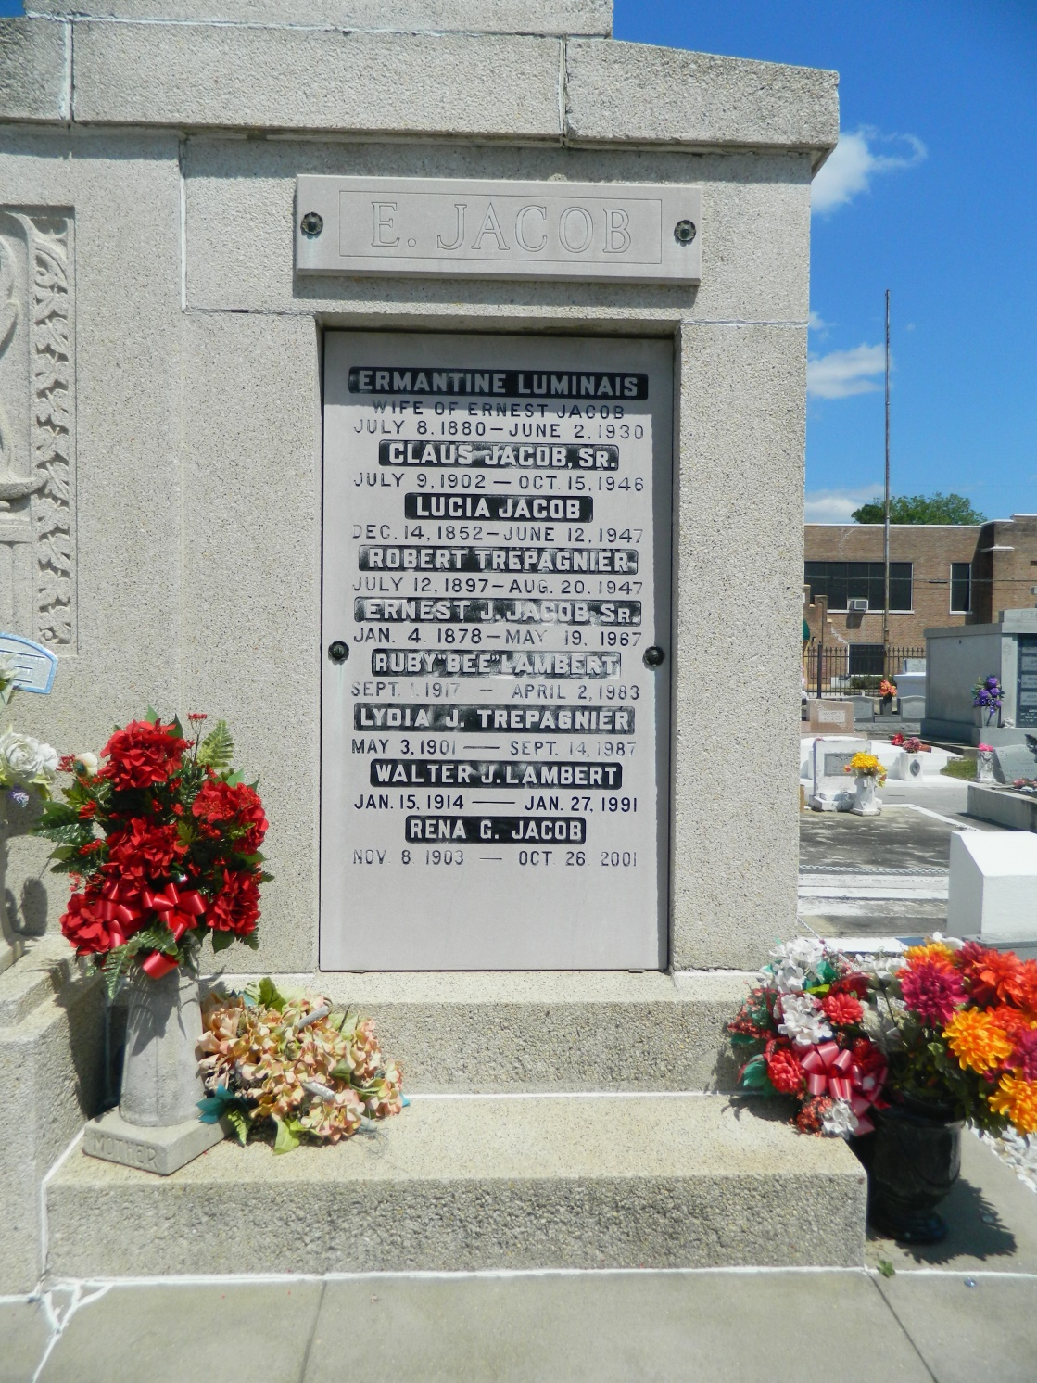

NORCO - Rena Giroir Jacob, 98, a native of Paincourtville and resident of Destrehan, died Oct. 26.  
 She was the wife of the late Claus Jacob Sr. and mother of Yolande St. Pierre and Curtis, Ronald and the late Claus Jacob Jr. She was also the daughter of the late Alcee and Irma Broussard Giroir and sister of Lillian Moriarty and the late Lawrence, Sidney, Alcee Jr., Charles, Clarence and Irma Giroir.  
 She is also survived by 20 grandchildren and 30 great-grandchildren.  
 Services were Oct. 29 at Sacred Heart of Jesus Catholic Church, Norco, with interment at St. Peter Cemetery, Reserve.

L'Observateur (La Place, LA) - Thursday, November 1, 2001

Contributed by Jane Edson