Velma (Millet) Jacob

August 11, 1927 – January 19, 2010

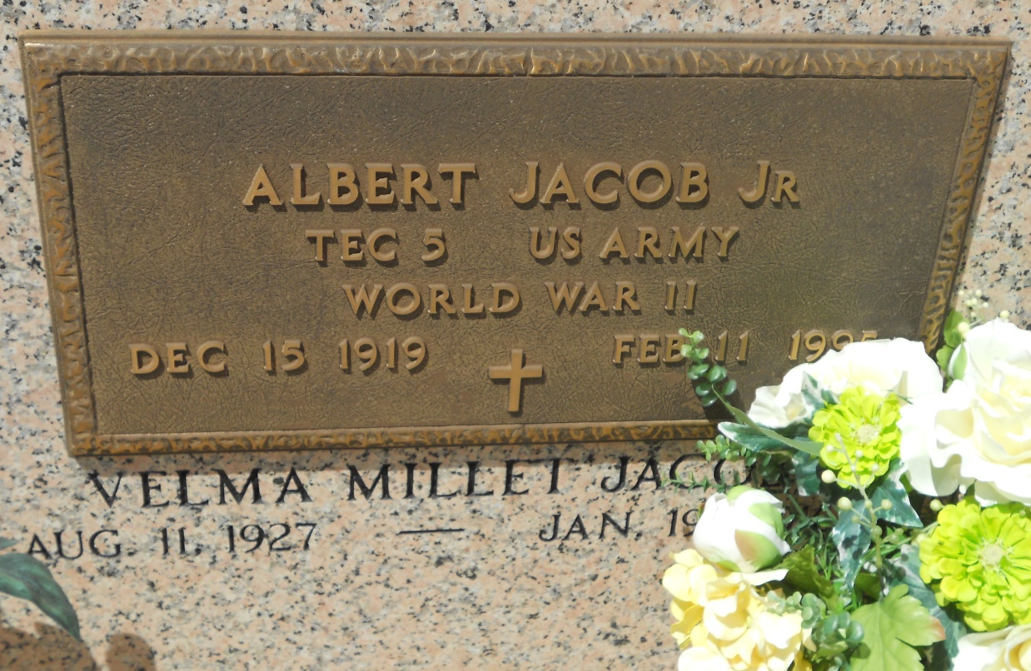

Photo by Team T Lo

Velma Millet Jacob passed away on Tuesday, January 19, 2010. Beloved wife of the late Albert Jacob, Jr. Mother of Cathy Jacob Reindl and husband Charlie, Susan Jacob Michel and husband David, Eric Jacob and wife Patty. Grandmother of Jon Smith, Seth, Lindsay and Jessica Michel and Blake Davis and Lance Jacob. Great-grandmother of Jacob, Abbe, Logan, Michael and Matthew. Daughter of the late Samuel and Corinne Millet. Sister of Dennis and Sammy Millet, Lucille Barthel and the late Elson (Biff), Earl (Mac), Irving, Raymond and Norman Millet and Edna Miano. Special sister-in-law Marie Millet. Also survived by many nieces and nephews. Age 82 years. A native of Lions, LA and a resident of Reserve. Miss Velma was known around Reserve for her beautiful and delicious cakes which she lovingly made for family and friends.  
  
Relatives and friends are invited to attend services. Visitation at St. Peter Catholic Church, Reserve on Thursday, January 21, 2010 from 9:00 am until 11:00 am. Followed by a Mass. Burial in St. Peter Cemetery. Arrangements by Millet-Guidry Funeral Home, LaPlace.

Times-Picayune, The (New Orleans, LA) - Thursday, January 21, 2010

Contributed by Jane Edson