Eric Christopher Joseph

November 10, 1967 – March 17, 2018

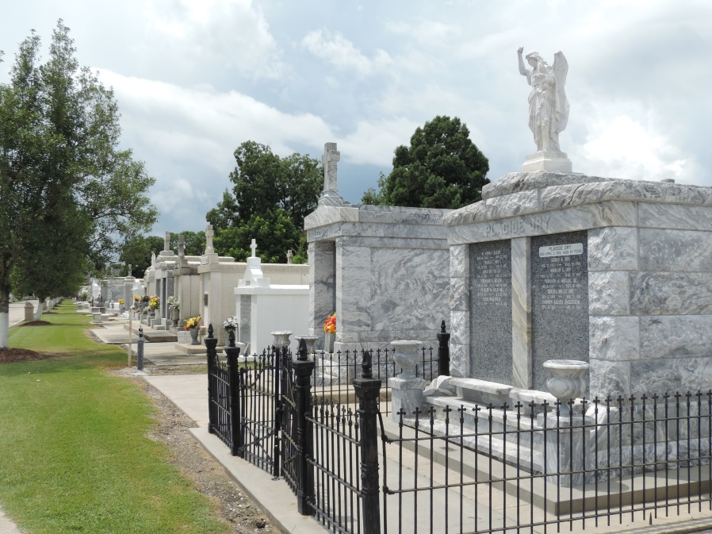

Eric “RaRa” Joseph passed on Saturday, March 17, 2018 of heart failure at Ochsner Medical Center, Kenner, LA., at the age of fifty. Eric was a lifelong resident of Reserve, LA. He was the son of the late Nellie Mae Keller Joseph and Alton Joseph, Sr. Brother of Alton Joseph, Jr., Tanger Frank and the late Angela Joseph Thomas. Also survived by other relatives and friends.

A Christian Memorial Service will be held on Monday, March 26, 2018 from Our Lady of Grace Catholic Church for 2:00pm, Rev. Christopher Amadi, SSJ, Celebrant. Interment at St. Peter Catholic Church Cemetery. Treasures of Life Funeral Services have been entrusted with his final care. 315 E. Airline Hwy, Gramercy, LA.  
“When someone you love becomes a memory, that memory becomes a TREASURE!”

[www.treasurefunerals.com](http://www.treasurefunerals.com) online obit (accessed 10/7/2018)