Marie Theresa (Weber) Keating

March 5, 1947 – September 25, 2018

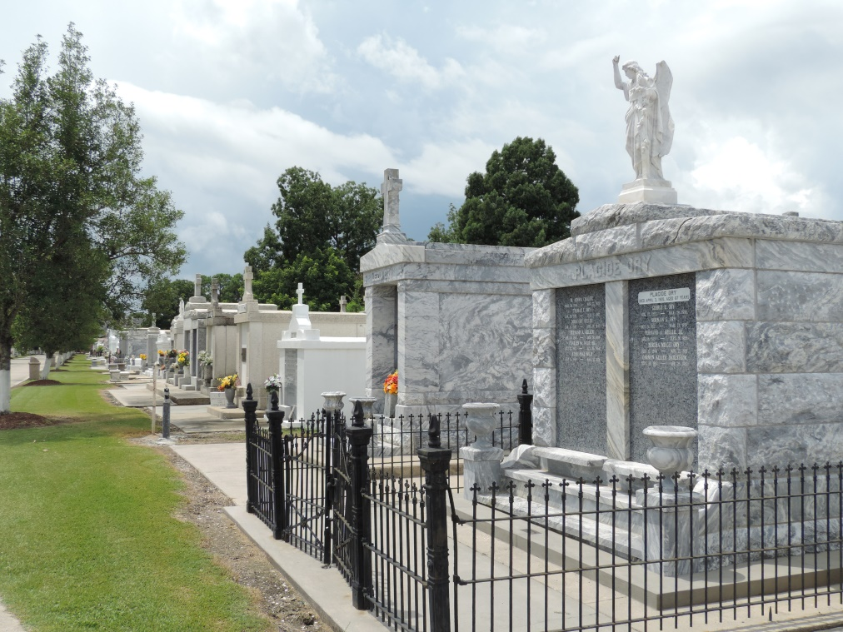

Marie Theresa Weber Keating, 71, of LaPlace, LA, went to meet our heavenly father on September 25, 2018. Theresa Keating, loving wife of Kenneth A. Keating, Sr., was a native of Reserve, LA and a resident of LaPlace, LA where she lived with the love of her life for 47 years. Mother of Kendra Glidden (Brent) and Kenneth A. ‘Kenny’ Keating, Jr. (Cara). Proud grandmother of Ashleigh Glidden Tumminello (Justin), Austin Glidden and Kolby Keating. Daughter of the late Harold J. Weber, Sr. and Theresa Aubert Weber. Sister of Harold J. Weber, Jr.

Theresa was a member of the Ladies Alter Society. She enjoyed spending time with her family and friends, but her greatest joy was playing with her grandchildren and watching them grow.

Relatives and friends are invited to attend the visitation at Millet-Guidry Funeral Home, 2806 W. Airline Hwy., LaPlace on Friday, September 28, 2018 from 11:00 a.m. until 1:45 p.m., followed by a Funeral Mass at St. Joan of Arc Catholic Church, 529 W. 5th St., LaPlace at 2:00 p.m. Interment in St. Peters Catholic Cemetery, Reserve, LA.

Millet-Guidry Funeral Home online obit (accessed 9/26/2018)