TEC 5 Arestide J. Keller

September 10, 1919 – March 12, 1945

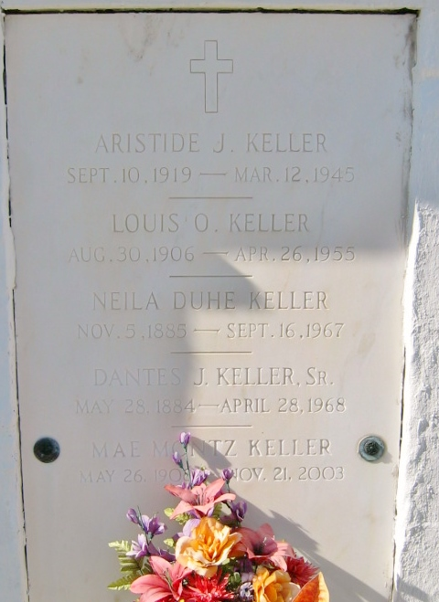

Photo by Bobby

U.S., World War II Army Enlistment Records, 1938-1946

Name: Arestide J Keller

Race: White

Marital status: Single, without dependents (Single)

Rank: Private

Birth Year: 1919

Education: Grammar school

Civil Occupation: Unskilled occupations in production of misc. food products

Enlistment Date: 21 Jun 1941, Jacksonville Army Air Field, Florida

Service Number: 34078681

Branch: Branch Immaterial - Warrant Officers, USA

Component: Selectees (Enlisted Men)

Source: Civil Life

Height: 67; Weight: 143

Notes: Cases reported by AGO only

*\*\*\*\*\**

U.S., Headstone Applications for Military Veterans, 1925-1970

Name: Arestide J Keller

Birth Date: 10 Sep 1919

Service Number: 34 078 681

Unit: 3575th Q.M.Truck Co

Enlistment Date: 21 Jun 1941

Discharge Date: 12 Mar 1945

Death Date: 12 Mar 1945

Cemetery: St Peter's Cemetery, Reserve, Louisiana, USA