May Ann (Delaneuville) Keller

March 9, 1936 – October 2, 2018

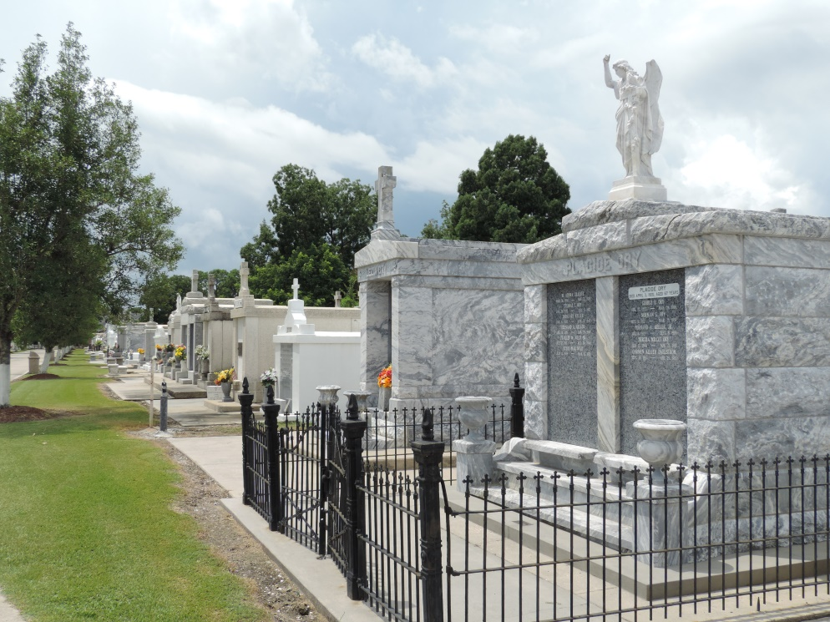

Mary Ann Delaneuville Keller passed away on Tuesday, October 2, 2018.

She was 82, a native and life-long resident of Reserve, LA. Beloved wife of the late Sidney ‘Snoz’ Keller, Jr. Mother of Cathy Duet (Jody), Ricky Keller (Tina) and the late Stanley P. ‘Snoz’ Keller. Grandmother of Emily, Chris (Amanda), Catherine, Matthew, Casey (Holly), Corey (Mamie) and Courtney (Chase). Great-grandmother of Lainey, Jace, Brant, Cole, Cooper and Cullen. Daughter of the late Lillian Granier Delaneuville and Horace Delaneuville, Sr. Sister of the late Mildred Rosetta, Henry Mire, Ronnie Delaneuville, Horace Delaneuville, Jr., Ruby Clement, Helen Borgeson, Edna Mae Duvielh and Hazel Fontana. Also survived by many nieces and nephews.

Relatives and friends are invited to attend the Funeral Mass at St. Peter Catholic Church, 1550 Hwy 44, Reserve on Friday, October 5, 2018 at 11:00 a.m. Visitation will begin in church at 9:00 a.m. Interment in St. Peter Cemetery. Arrangements by Millet-Guidry Funeral Home.

Millet-Guidry Funeral Home online obit (accessed 10/3/2018)