Morgan J. Keller

1936 – October 23, 1999

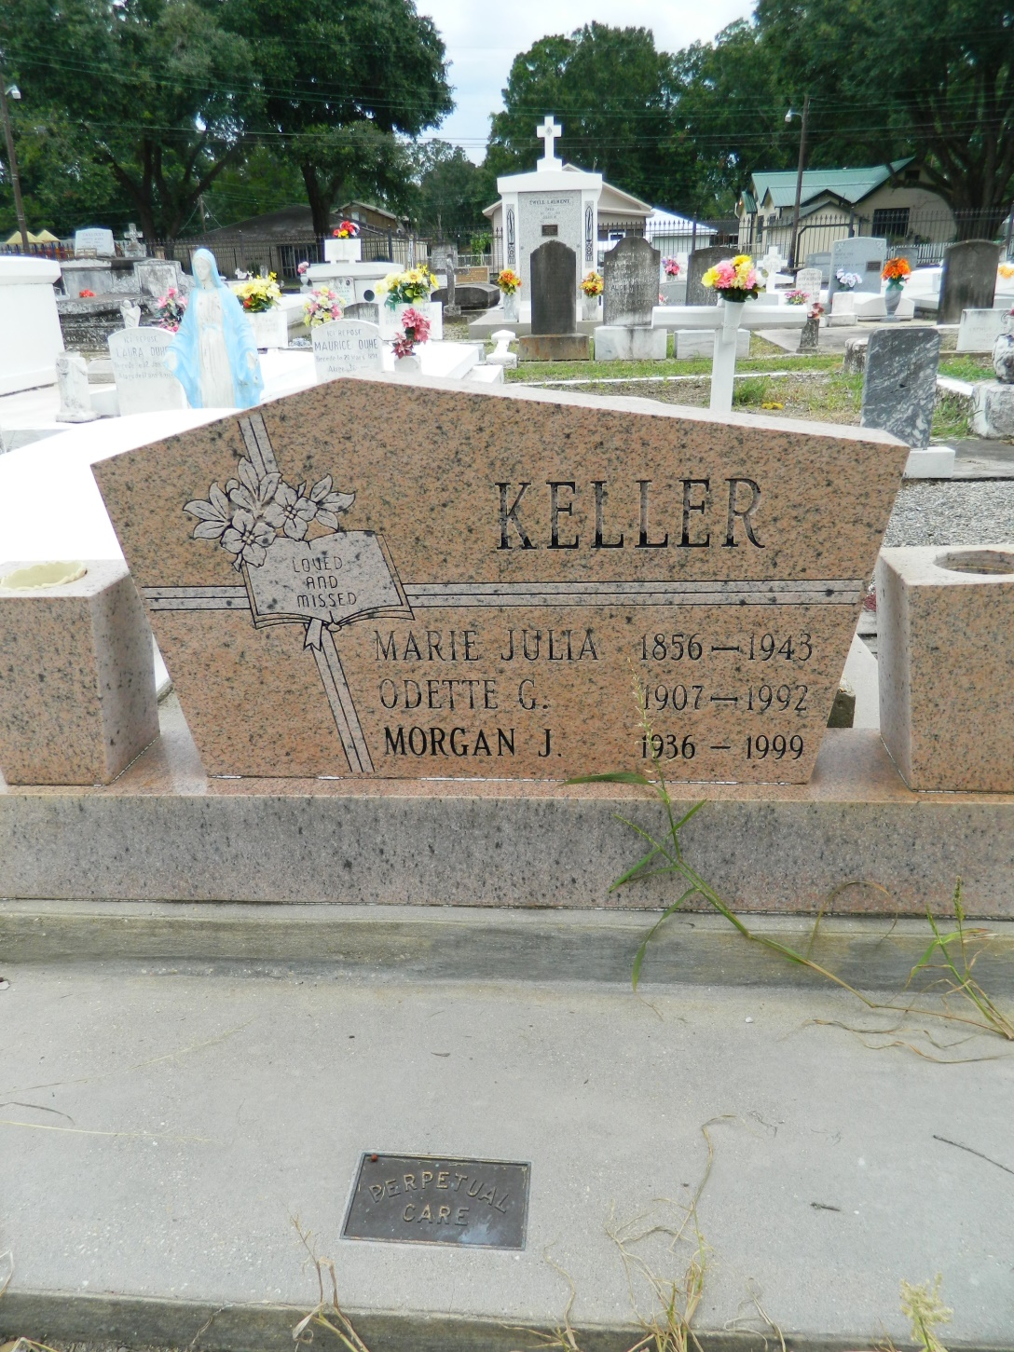

LAPLACE - Morgan J. Keller, 63, a native and resident of Reserve, died Oct.23. He was the son of the late Sidney and Odette Gueret Keller and brother of Marie Vicknair, Dolores, Eugene and Gerald Keller and the late Gloria Perilloux and Sidney Keller Jr. Services were held Oct. 26 at St. Peter Church, Reserve, with interment at the church cemetery.

L'Observateur, LaPlace, LA; October 27, 1999