PFC Henry J. LaBranche

March 24, 1911 - November 10, 1944

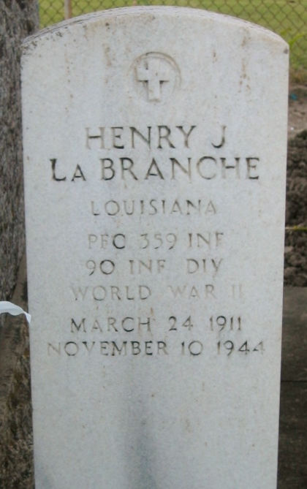 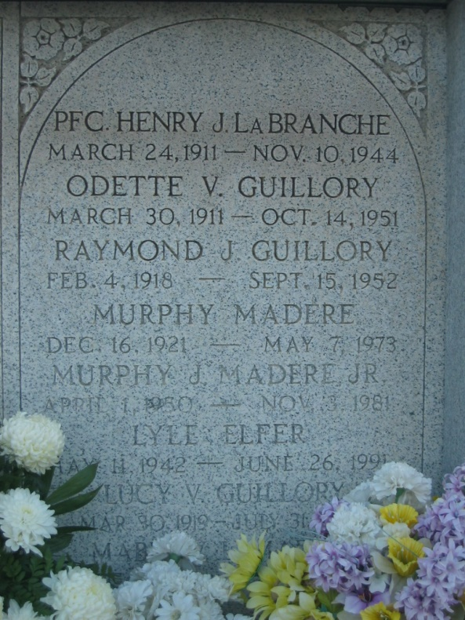

Photos by Bobby

PFC Henry J LaBranche of Laplace, Louisiana, died in the service of his country in France on 10 Nov 1944 at age 33 years. He was the husband of Mabel Vicknair and the father of Sherry Ann Zene and Henry LaBranche Jr. Services were Friday 17 Sep 1948 at St Peter Church, Reserve, Louisiana, with interment in St Peter Cemetery.

From Obituary, The Times-Picayune 17 Sep 1948

Contributed by Dwayne Montz