Imelda (Kugler) Laiche

April 15, 1911 – December 8, 2000

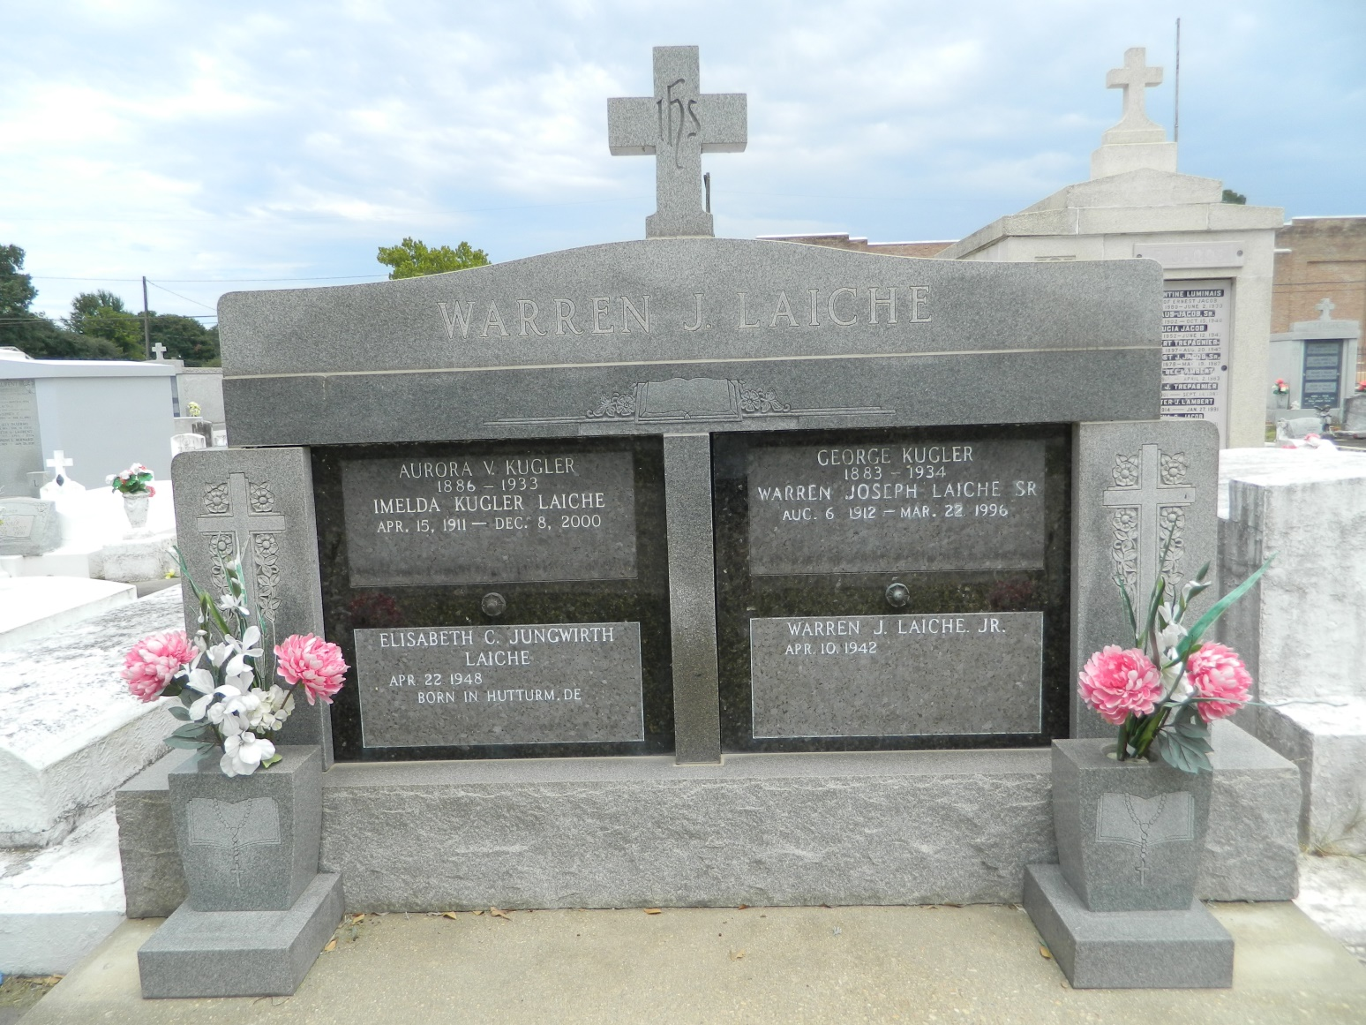

LAPLACE - Imelda Kugler Laiche, 89, a native of Norco and resident of LaPlace for 64 years, died Dec. 8. She was the wife of the late Warren Laiche Sr., and mother of Mary Bickford and Warren Laiche Jr. She was also the sister of Laura Theral and the late Rosalie Laiche and Fritz and Irving Kugler. She is also survived by five grandchildren and two great-grandchildren.

Services were Dec. 12 in the chapel of Millet-Guidry Funeral Home, LaPlace, with interment at

St. Peter Cemetery, Reserve.

L'Observateur, LaPlace, LA; December 13, 2000

Contributed by Jane Edson