Claude Andre Levet

March 17, 1958 – October 19, 2018

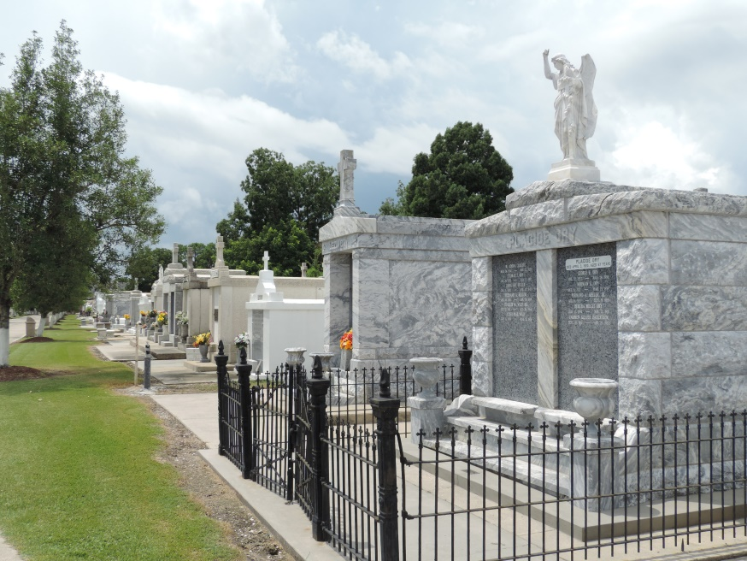

Claude Andre Levet, age 60, passed away peacefully on October 19, 2018 after a courageous battle with brain cancer. He was a native of Garyville/Lions, LA, and resided in Charlottesville, VA. Claude graduated from Loyola University New Orleans in 1982. He was a living historian who viewed history thru his “Wet Plate” collodion photography.

Claude was a devoted and loving husband to his wife, Zebee McCullough Levet for 14 years. Loving brother to Lawrence “Larry” Levet (JoAnn), Emilie “MiMi” Blank, Yvette Dornier (Benny), Angelique “Angel” Aycock, and Jacques Levet (Yvette). He will also be sadly missed and forever remembered by his numerous nieces and nephews, extended family, and dear friends.  
He was preceded in death by his mother, Myrtle P. Levet; father, Carl L. Levet; brother, Carl “Putsy” Levet; and nephew, Lawrence “Perry” Levet.

Relatives and friends are invited to attend the visitation at St. Peter’s Catholic Church, 1550 Hwy 44, Reserve, LA on Saturday, November 3, 2018 from 9:00 a.m. to 11:00 a.m., followed by a Funeral Mass at 11:00 a.m. Interment will be in St. Peter’s Cemetery. Arrangements by Millet-Guidry Funeral Home.

Millet-Guidry Funeral Home online obit (accessed 10/23/2018)