Bernadine Elaine (Aubert) Lipps

May 19, 1946 – November 8, 2008

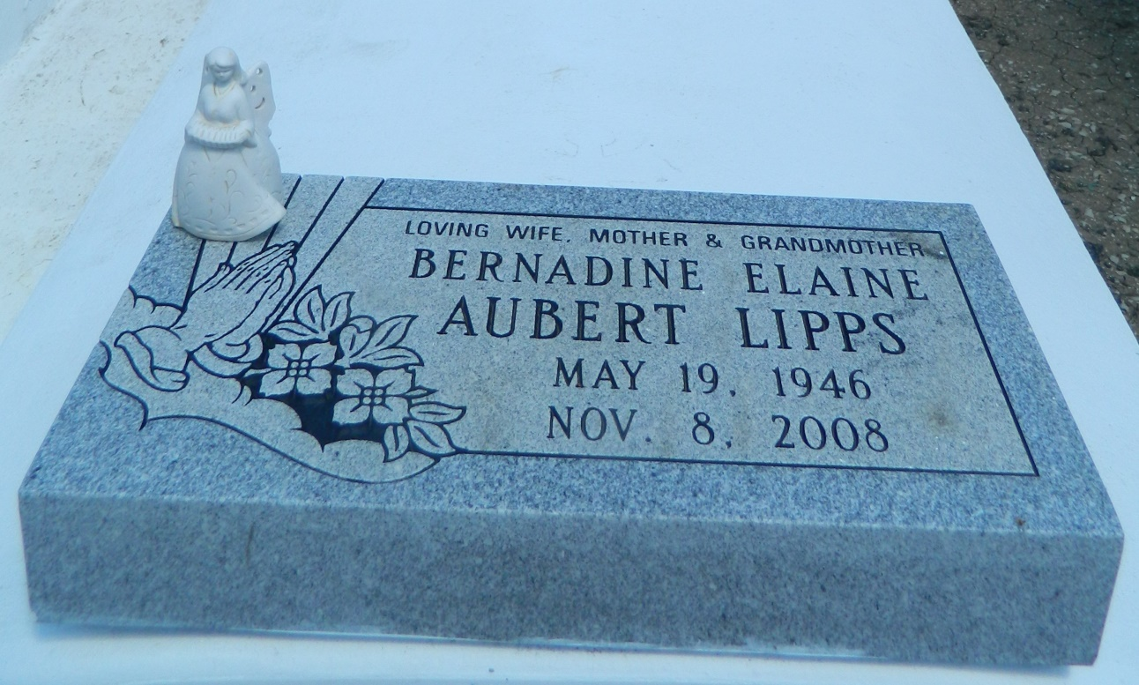

Bernadine Aubert "Bern" Lipps of Reserve, 62, died Saturday, November 8, 2008. She was wife of Michael Lipps Sr, daughter of Harold Aubert and the late Shirley Johnson Aubert, mother of Michele Lewis, Michael Jr., Ray, Angela, Patrick, Shirley Lipps, Anika Harris and the late Denise Lipps and sister of Sherry Burnette, Diane Aubert, Catherine Aubert, Carol Taylor, Veronica Aubert, Sharon Goff, Harold Aubert Jr., Randy Paul Aubert and the late Gary Aubert. She is also survived by a host of nieces, nephews and other relatives.  
  
Relatives and friends of the family, priest and parishioners of Our Lady of Grace Catholic Church and neighboring churches, employees of St. James Behavioral Health Hospital, Summerville Assisted Living, HBS-Shell Norco and Herzing College are invited to attend a mass of Christian burial on Saturday, November 15, at 10 a.m. at Our Lady of Grace Catholic Church in Reserve, Father Joseph Rodney officiating. Interment at St. Peter Catholic Church Cemetery in Reserve. Visitation at the church after 8 a.m.

L'Observateur (La Place, LA) - Friday, November 14, 2008

Contributed by Jane Edson