Denise D. Lipps

February 1, 1975 – July 3, 2005

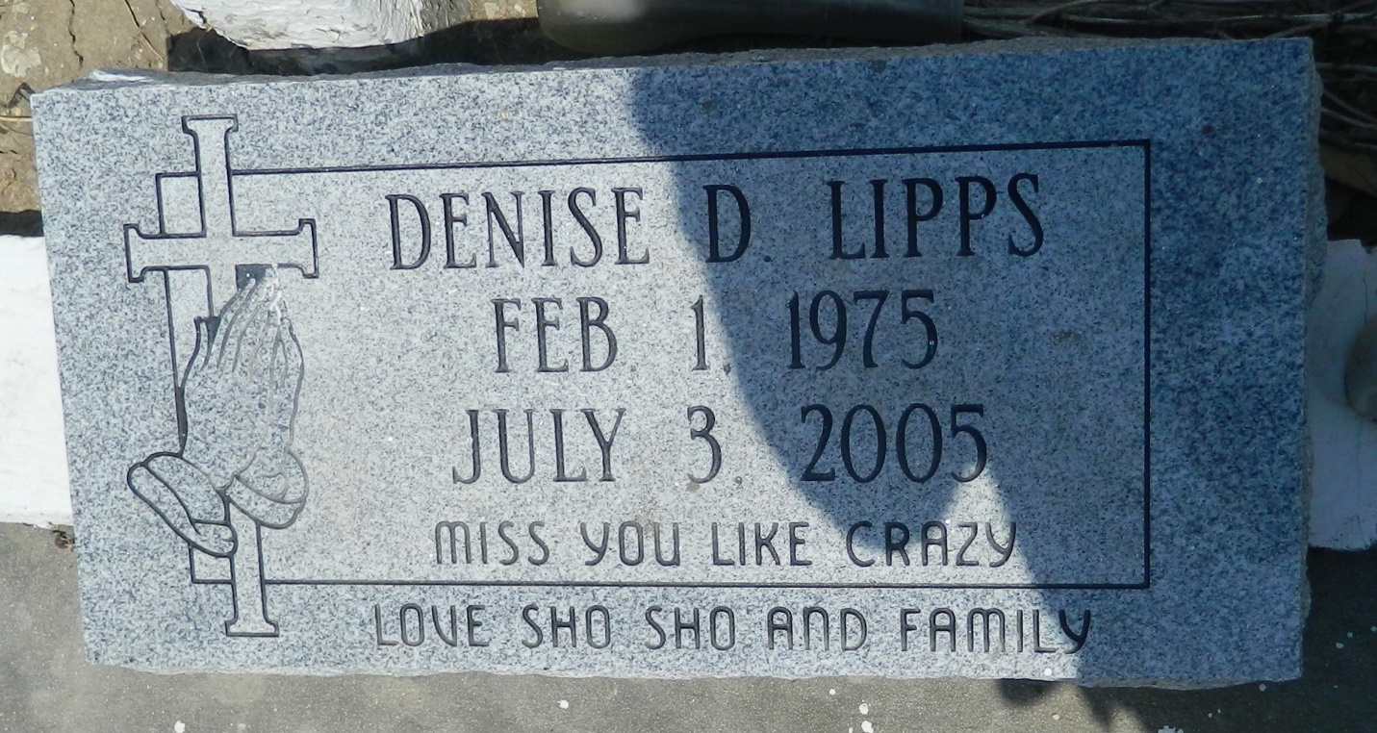

Reserve woman dies in accident after car flips

A Reserve woman was killed after she lost control of her car early Sunday, Kenner police said.  
 Denise Lipps, 30, was killed when her 1999 Nissan Altima flipped over on Third Street near Alliance Street in Kenner about 4:45 a.m., Kenner police spokesman Capt. Steve Caraway said. Witnesses said Lipps was driving fast when she lost control of her car. Lipps was pinned inside the vehicle after it flipped over, Caraway said. She died on the scene, he said.  
 The car's speed was a determining factor in the accident, Caraway said, adding that toxicology tests will determine whether alcohol also was a factor.

Times-Picayune, The (New Orleans, LA) - Monday, July 4, 2005

Contributed by Jane Edson