Michael Mercier Lipps Sr.

November 14, 1940 - September 26, 2019

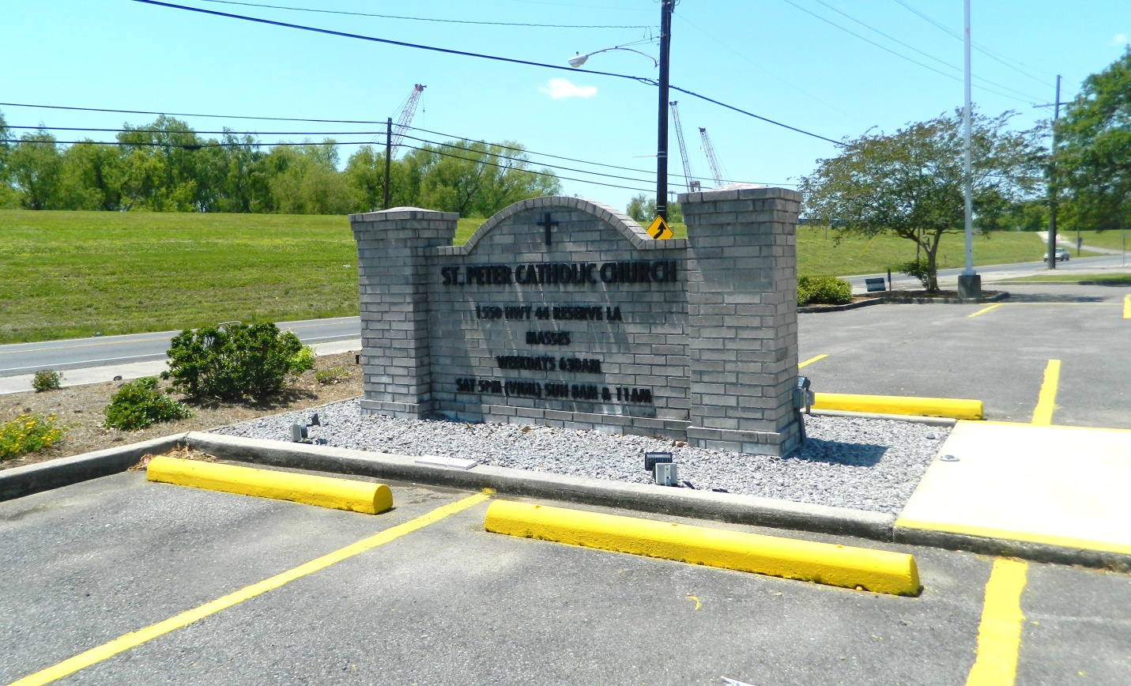

Michael M. Lipps Sr. (78) departed his earthly life on September 26, 2019 at his residence. He leaves to treasure his memory 8 kids. Michele Lewis, Michael Lipps Jr., Ray Lipps, Angelia Lipps, Patrick Lipps Sr., Shirley Lipps, Anika Lipps and Shanquita Pitts. He also leaves 21 grandkids, and 18 great grandkids.   
  
Relatives and friends, coworkers, former coworkers of the family, Shell Oil, Motiva employees, RiverPlace Behavioral Health, and St. Catherine’s Hospice and all neighboring churches are invited to attend a Mass of Christian Burial at Our Lady of Grace Catholic Church 772 Hwy 44, Reserve, LA on Saturday, October 5, 2019 at 10:00 a.m., Father Christopher Amadi, Celebrant. Visitation will begin at 8:15 a.m. Entombment at St. Peter’s Catholic Church Cemetery. Final care has been entrusted to Treasures of Life Funeral Services, 315 E. Airline Hwy Gramercy, LA 70052.

Treasure of Life Funeral Services, Gramercy, LA; January 29, 2020