Alfred Joseph Louque, Jr.

October 15, 1928 – January 27, 2001

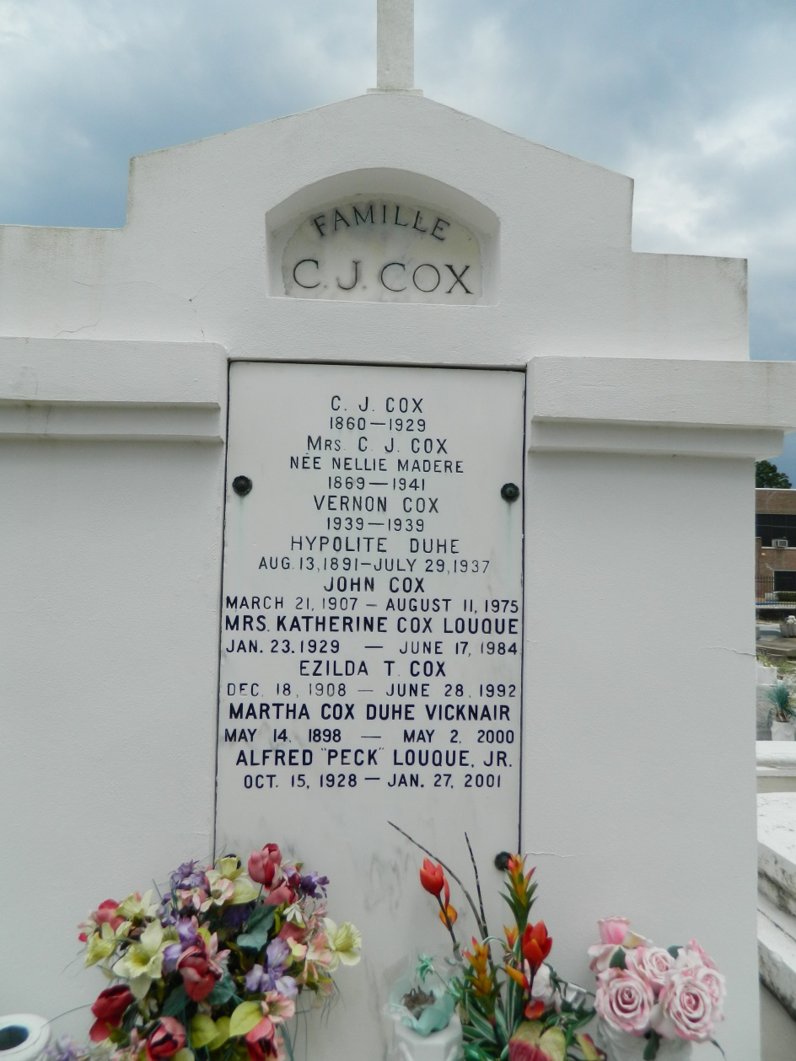

LOUQUE RESERVE - Alfred Joseph "Peck" Louque Jr., 72, a native and resident of Hester, died Jan. 27. He was the husband of the late Katherine Cox Louque and father of Sally Roussel and Alfred "Lucky" III, Glenn, Robin and Joey Louque. He was also the son of the late Alfred Sr. and Melodia Roussel Louque and brother of six surviving sisters and six surviving brothers. He was preceded in death by one brother. He is also survived by 12 grandchildren and three great-grandchildren. He was preceded in death by one grandchild. Services were Jan. 30 at St. Peter Catholic Church, Reserve, with interment at the church cemetery.

**L'Observateur (La Place, LA) - Wednesday, January 31, 2001**

**Contributed by Jane Edson**