Tracy Paul Luminais

August 14, 1957 - February 8, 2020

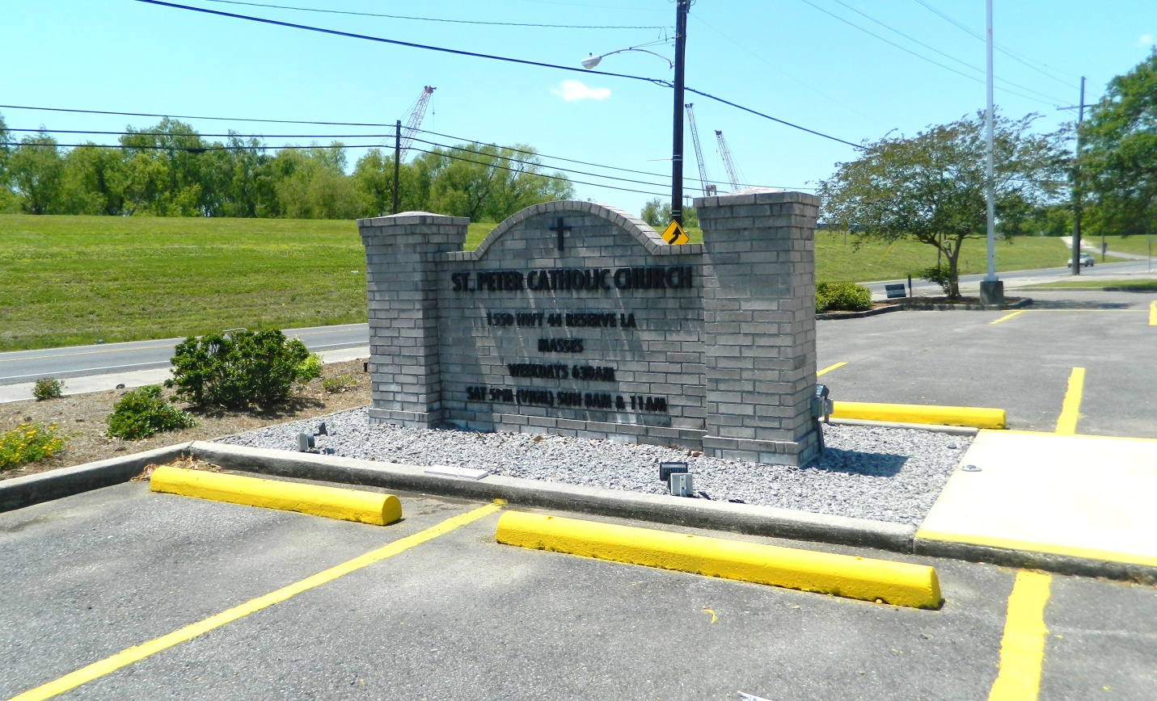

Tracy Paul Luminais passed away on Saturday, February 8, 2020 at the age of 62. He was born in New Orleans, LA and a resident of Reserve, LA.  
 Beloved husband of Dedra Clement Luminais. Father of Mandy and Megan Luminais. Son of the late Janice Ockman and Floyd Luminais. Brother of Trina Luminais Louviere and Trudy Luminais Trepagnier. Son-in-law of Wanda Clement and the late J.P. Clement.  
 Tracy was a caring, humble, family man, a community philanthropist and mentor, who touched the lives of so many people. He was a true inspiration, and he will be greatly missed by his family, friends, and entire community.  
 Relatives and friends are invited to attend the Funeral Mass at St. Peter Catholic Church, 1550 Hwy 44, Reserve on Friday, February 14, 2020 at 11:00 a.m. Visitation at church from 9:00 a.m. to 11:00 a.m. Interment in St. Peter Cemetery.  
 Donations can be made in his memory to Ochsner Health System, Department of Philanthropy, 1514 Jefferson Hwy., BH 607, New Orleans, LA 70121. Arrangements by Millet-Guidry Funeral Home

Millet-Guidry Funeral Home, LaPlace, LA; February 13, 2020