Leslie (Lasseigne) Mabile

August 6, 1911 – November 9, 2002

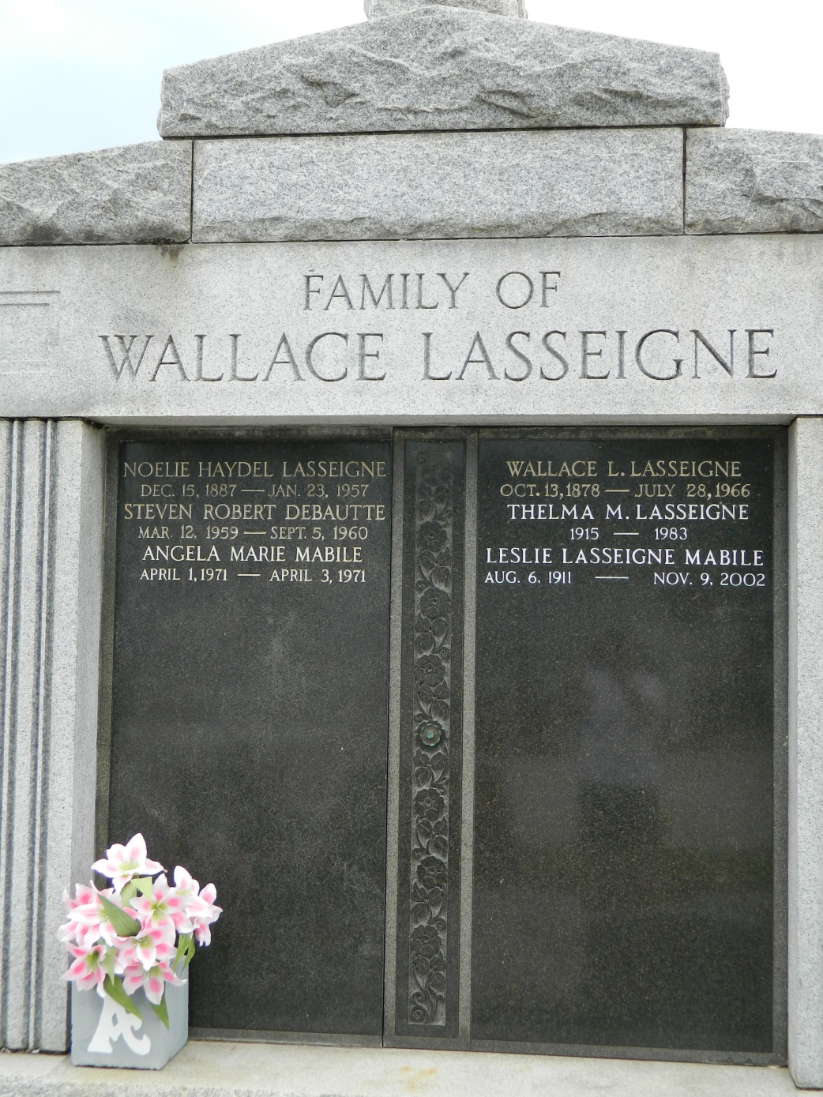

LAPLACE - Leslie Lasseigne Mabile, 91, a native and resident of Reserve, died Nov. 9. She was the wife of the late Paul Mabile and mother of Gloria Triche.   
 She was the daughter of the late Wallace and Noelie Haydel Lasseigne and sister of Mabel Montz, Ruby Dubroc and the late Jennie Mabile and Robert, Thelma, Larry and Roline Lasseigne.   
 She is also survived by three grandchildren and four great-grandchildren.   
 She was a former typesetter from the late 1930s to the late 1960s for L'Observateur and the daughter of the newspaper's founder.   
 Services were Nov. 11 in the chapel of Millet-Guidry Funeral Home, LaPlace, with interment at St. Peter Cemetery, Reserve.

**L'Observateur (La Place, LA) - Sunday, December 1, 2002**

**Contributed by Jane Edson**