Judith Ann (Dupepe) Mannina

August 18, 1936 – January 20, 2005

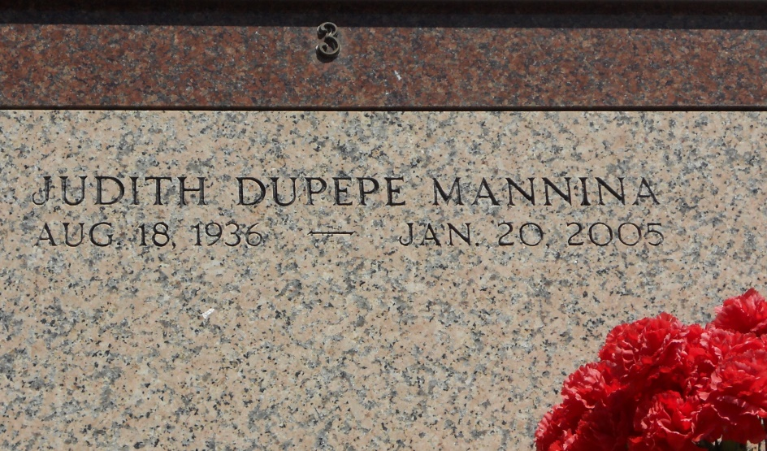

Photo by Team T-Lo

Judith Dupepe Mannina on Thursday, January 20, 2005 at 3:40 A.M. Beloved wife of Earl Mannina. Mother and mother-in-law of Dean and Janet Mannina. Grandmother of Nicholas Mannina. Daughter of the late Nicolle Sr. and Eulalie Dupepe. Sister and sister-in-law of Clarence and Harriet (Patsy) Dupepe, Nicolle Jr. (Sonny) and Carole Dupepe, Julian Guidry and the late Velma D. Guidry and Norman Dupepe. Age 68. A native of Reserve, former resident of Norco, and a current resident of LaPlace for the last 8 years. Relatives and friends of the family are invited to attend services. Visitation at St. Joan of Arc Catholic Church, 529 W. 5th St., LaPlace on Saturday, January 22, 2005 from 9:30 A.M. to 12:00 P.M. followed by religious services at the church at 12 noon. Burial in St. Peter Cemetery, Reserve. In lieu of flowers, masses preferred. Arrangements by Millet-Guidry Funeral Home, LaPlace.

Times Picayune, New Orleans, Louisiana; January 21, 2005