Juliette (Maurin) Maquar

June 18, 1925 – October 26, 2014

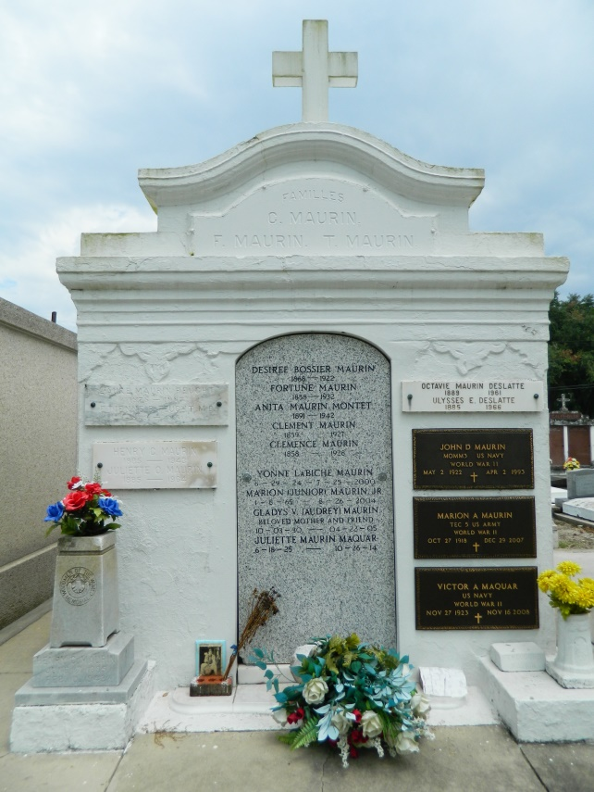 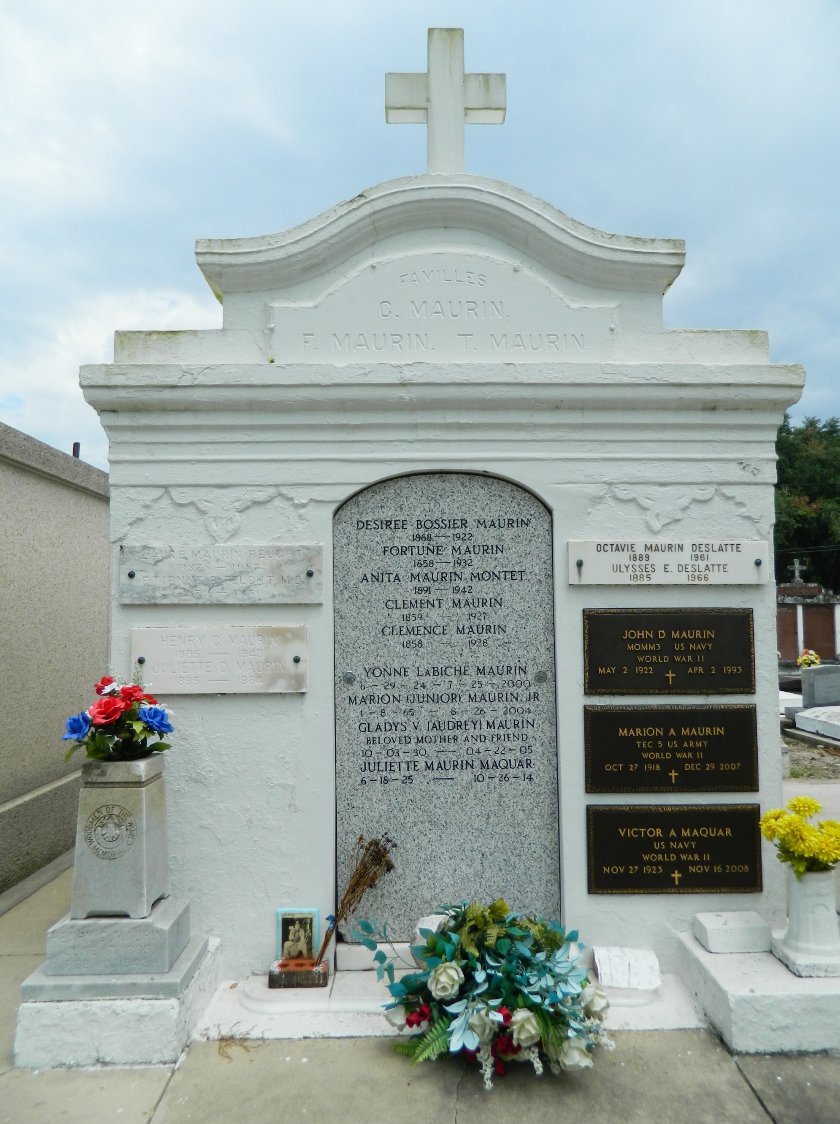

Juliette Maurin Maquar passed away on Sunday, October 26, 2014 at the age of 89. She was a native and resident of LaPlace. Beloved wife of the late Victor 'Vic' Maquar. Mother of Charlotte Iriarte (Juan), Cynthia LeBlanc (Jerry and the late Perry Harrison) and Cheryl Entremont (Mark). Daughter of the late Juliette Ory Maurin and Henry C. Maurin. Sister of the late Cecile Cambre, Henry Maurin, Marion Maurin and Dan Maurin. Grandmother of Ryan Iriarte (Alison), Adam Iriarte, Lawrence Orbeck, III, David Entremont, Julie Entremont, Jessica Harrison and Drew Harrison. Great-grandmother of Ayda Iriarte, Delaney Harrison, Avery Harrison Daniels and Zeke Harrison. Also survived by 1 niece and 5 nephews.

Ms Maquar received the Certificate of Merit (Knights of Columbus), The St. Louis Medallion, The Outstanding Citizen of the Year (Rotary Club), The George Award (LaPalce Lions Club), The Presidential Award of Honor (Jaycees-Toys for Tots), The Pope John Paul II Award and received communion from Pope John Paul II. Juliette's passion to help the needy began with her volunteering through The Sodality of St. Joan of Arc Mission Church. She was a member of The Alter Society, The Board of Directors for Catholic Charities, More than a Meal Program (First Methodist Church), Toys for Tots Program, Christmas Basket Program (Lions Club), Thanksgiving Basket Program (St. Joan of Arc School), Retired Senior Volunteer Program, St. Joseph Cookies, VFW Ladies Auxiliary Post 3337 and CCD Religious Education Program. She was the founder of The St. Joan of Arc Thrift Shop, was a president of St. Vincent De Paul Society and had the honor of meeting Mother Theresa in New Orleans.   
 Relatives and friends are invited to attend the Funeral Mass at St. Joan of Arc Catholic Church, 529 W. 5th St., LaPlace on Thursday, October 30, 2014 at 1:00 p.m. Visitation will begin in church at 10:00 a.m. Interment in St. Peter Cemetery. In lieu of flowers, Masses preferred.   
 Arrangements by Millet-Guidry Funeral Home. To view or sign the online guest book, please visit [www.milletguidry.com](http://www.milletguidry.com/)

**Times-Picayune, The (New Orleans, LA) - Wednesday, October 29, 2014**

**Contributed by Jane Edson**