Jean Marse, Jr.

May 3, 1944 - February 7, 2020

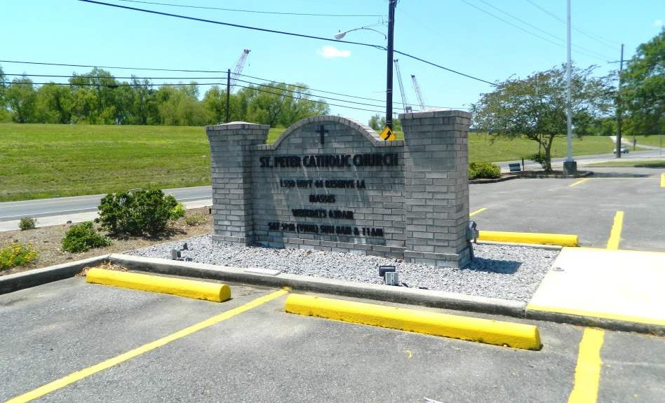

Jean Marse, Jr. passed away peacefully in the presence of family and friends on Friday, February 7, 2020 at the age of 75.  
 He is survived by the love of his life, his wife of 55 years, Cynthia Roussel Marse, his daughter Lisa Marse Manzella and son-in-law Brian, his son Darren Marse and daughter-in-law Angela, and his beloved granddaughters Natalie and Caroline Marse. Jean is also survived by his brother Kevin Marse (Diana) and sister Yohanna Marse Lorio (Greg), sister-in-law Joy Roussel, brother-in-law Charles Robicheaux, and many nieces, nephews, cousins, and dear friends.  
 He was preceded in death by his parents Jean Marse, Sr. and Rose Nattie Gondolfo Marse, his adored grandmother Nonna, his in-laws Hubert “Cadie” and Noelie Roussel, brother-in-law Hubert “Poochie” Roussel, Jr., sister-in-law Barbara Roussel Robicheaux, and his nephew Randy Roussel.  
 He was born in Reserve, LA on May 3, 1944 and resided there for over 70 years until moving to New Orleans, LA in 2016. He retired from Monsanto Chemical in 1999. Jean was quite the avid movie-goer, where he could most likely be found in a theater every Tuesday. He enjoyed family vacations, fishing, crabbing, shrimping, and LSU Football, but most enjoyed spending time with his family and friends. He was extremely proud of his children and their accomplishments and adored his granddaughters, who were the lights of his life. He never met a stranger and greeted everyone with his contagious smile. To know Jean was to love him.  
 The family would like to thank the doctors and staff of Ochsner Medical Center for the excellent care he received.  
 Relatives and friends are invited to attend the Funeral Mass at St. Peter Catholic Church, 1550 Hwy 44, Reserve on Wednesday, February 19, 2020 at 12:00 p.m. Visitation at the church will be held from 10:00 a.m. to 12:00 p.m. Interment in St. Peter Cemetery to follow. In lieu of flowers, masses preferred or please consider a donation in his memory to Perry’s Posse, P.O. Box 2053, Garyville, LA 70051.

Millet-Guidry Funeral Home, LaPlace, LA; February 14, 2020