Gladys “Audrey” (Vicknair) Maurin

October 3, 1930 – April 22, 2005

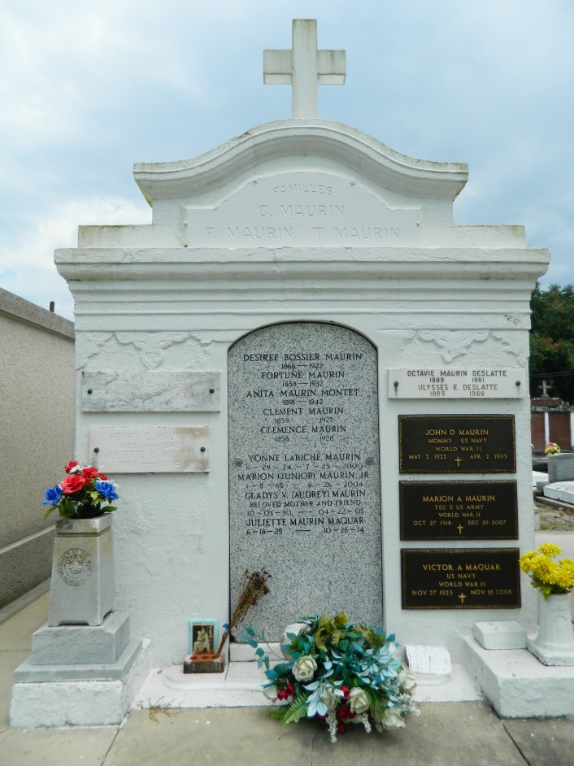 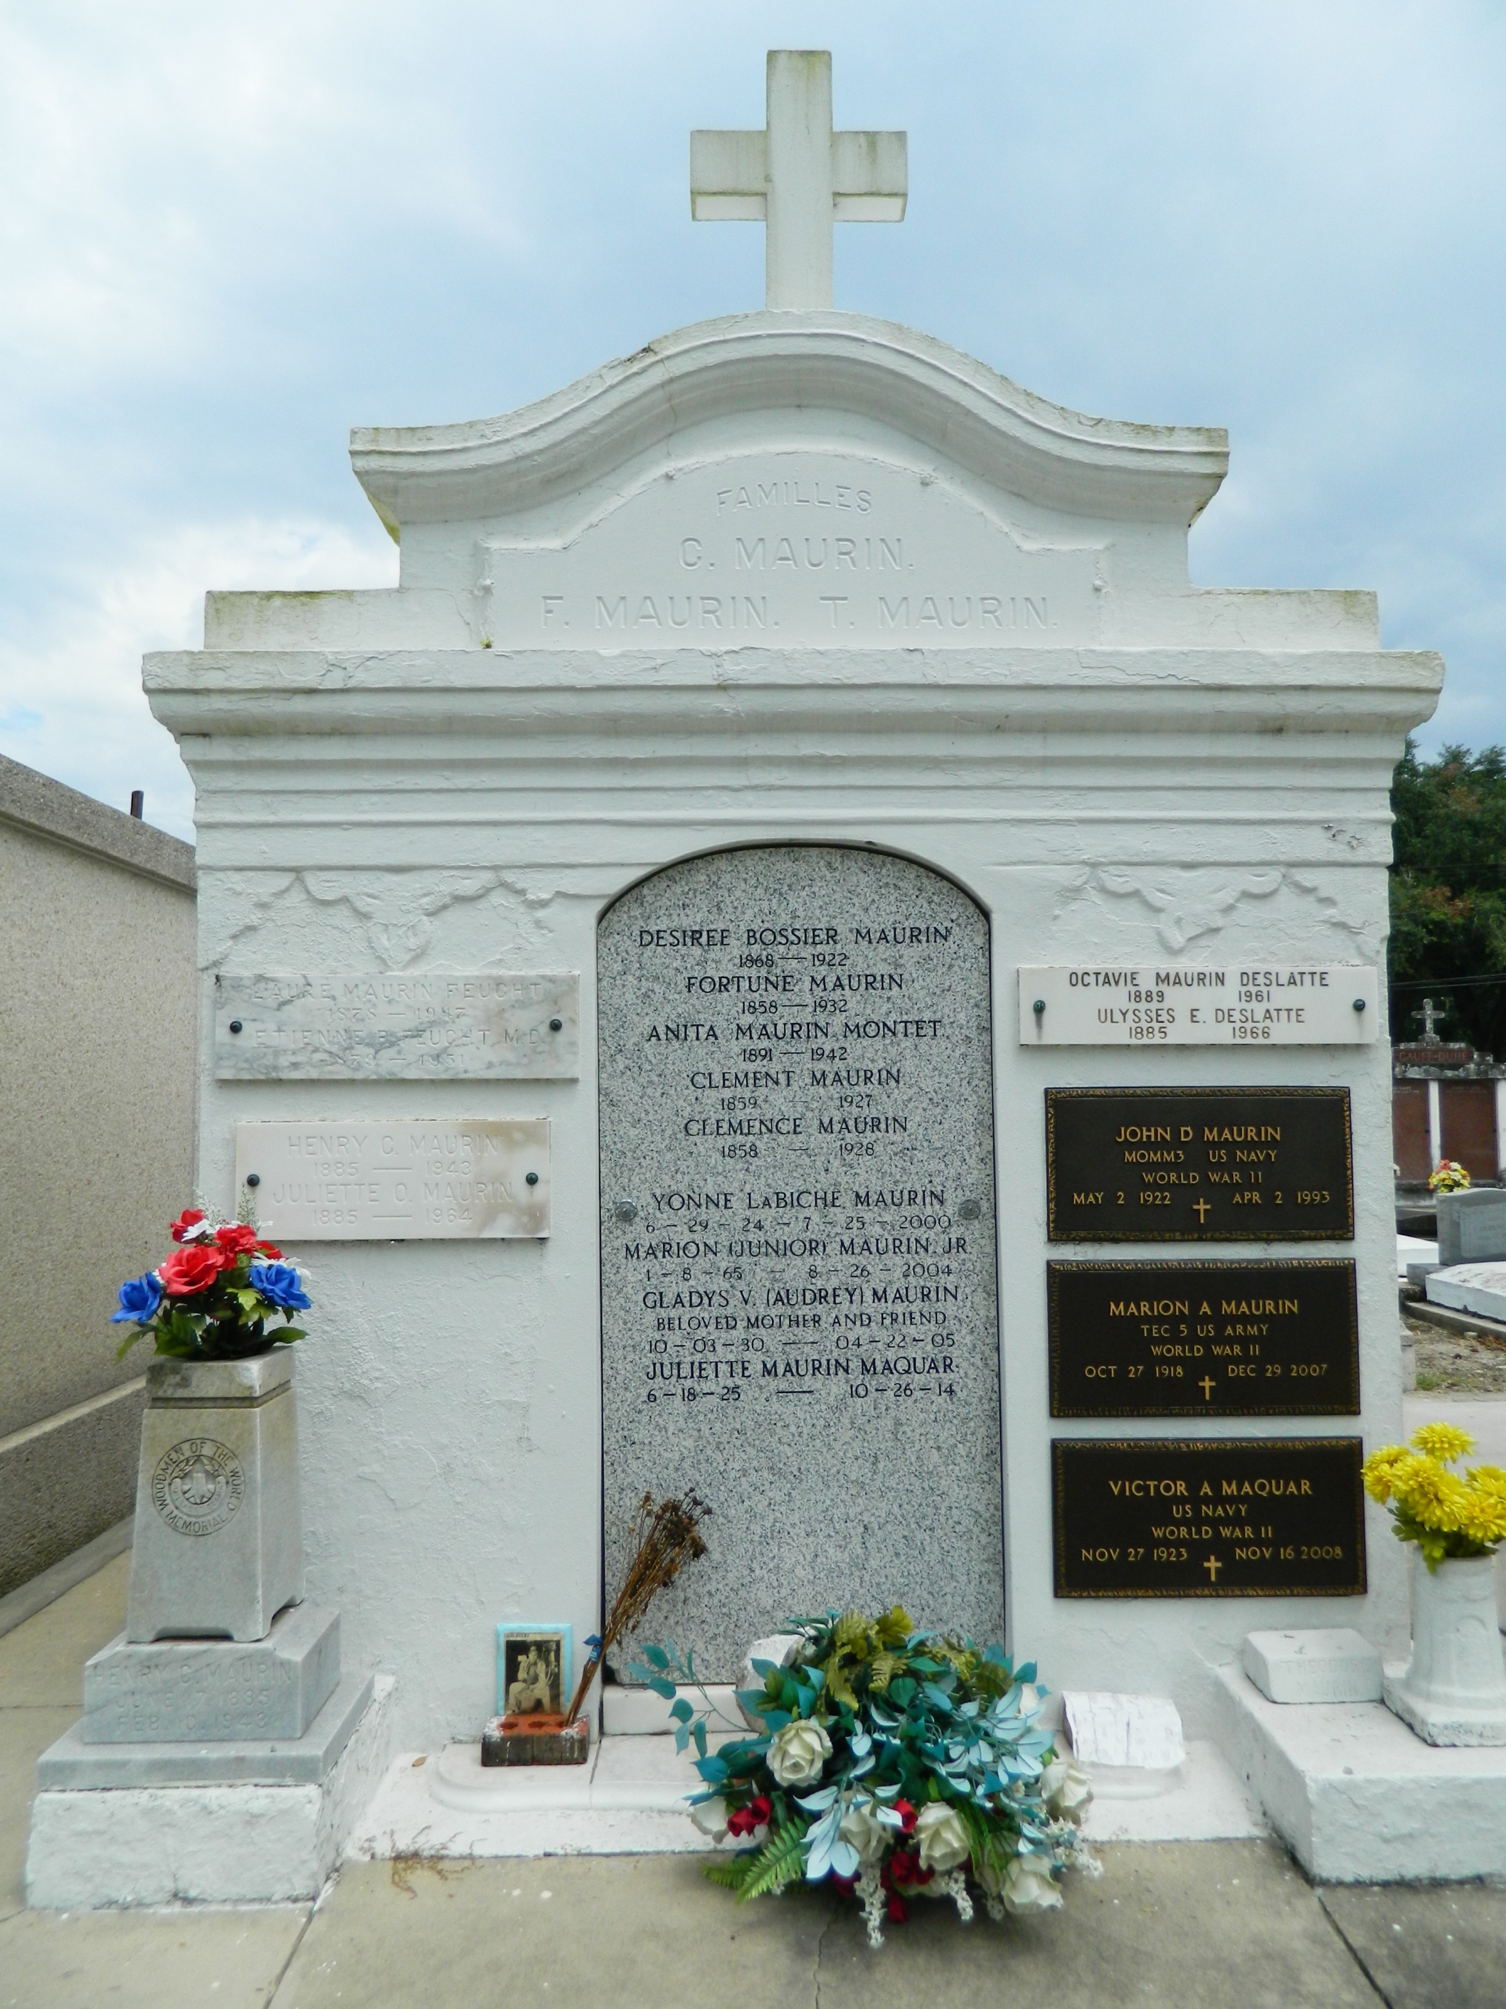

LAPLACE - Gladys (Audrey) Vicknair Maurin, 74, a native of Reserve and resident of LaPlace, died April 22.   
  
She was the wife of the late John Dan "Sam Spade" Maurin.   
  
She is survived by her children J.D. and Gregory Maurin and Linda M. Stein. She is also survived by nine grandchildren, her brother Peter Vicknair and her sister Mary Helen Scioneaux.   
  
Services will be held today at 10 a.m. at the St. Joan of Arc Catholic Church, LaPlace, with internment in the St. Peter Cemetery, Reserve.

**L'Observateur (La Place, LA) - Wednesday, April 27, 2005**

**Contributed by Jane Edson**