Louis Joseph “L J” Maurin, Jr.

January 2, 1919 – August 31, 2005

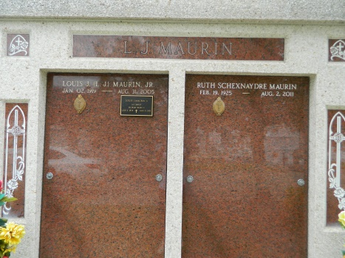

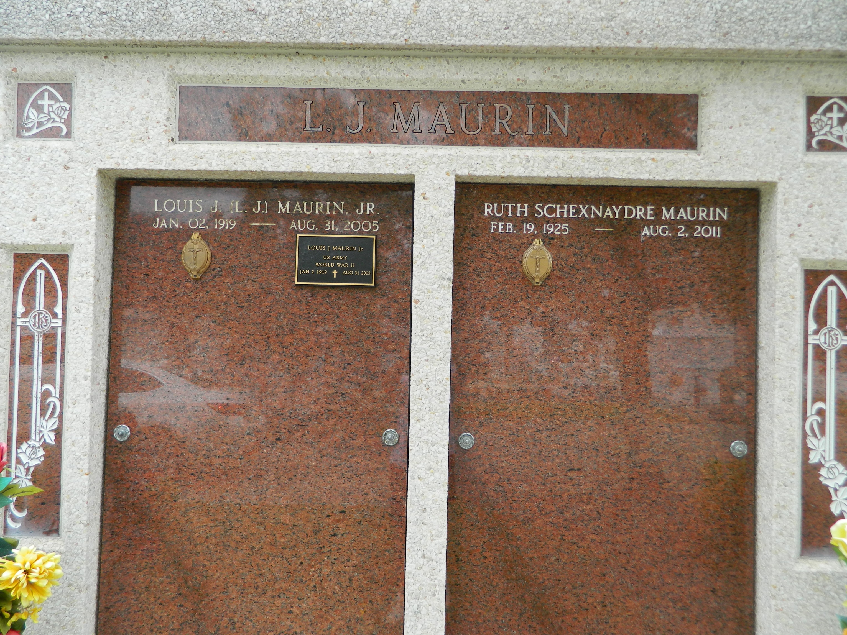

Louis "L.J." Joseph Maurin Jr. died at 10:40 p.m. on Wednesday, Aug. 31, 2005, at age 86. He was the beloved husband of Ruth Schexnaydre Maurin; loving father of two sons, Louis III and David; three daughters, Emma Lou Boé, Patricia Bossier and Deborah Baudouin; father-in-law of Sharon McRae Maurin, Donna Voilion Maurin, Caire Boé, Dr. Gerard J. Bossier and William Baudouin; son of the late Louis J. Maurin Sr. and Emma LeBrun; brother of Elaine Delaneuville, Marjorie McTopy, Marie Therese Montz, Jo-Ann Montz, the late Gloria Oubre and J. Lebrun Maurin. He is also survived by 10 grandchildren, three great-grandchildren, three stepgrandchildren and four stepgreat-grandchildren.

He was a lifelong resident of Reserve in St. John Parish, a World War II veteran, having served from 1941-1946 with the 94th Infantry Division in central Europe.

Relatives and friends of the family are invited to attend visitation at St. Peter's Catholic Church, Reserve, on Monday, Sept. 5, from 8 a.m. until religious service at 10 a.m. Interment in St. Peter's Cemetery. In lieu of flowers, donations may be made to the Kidney Foundation or the American Red Cross for Hurricane Katrina relief.

**Advocate, The (Baton Rouge, LA) - Sunday, September 4, 2005**

**Contributed by Jane Edson**