Marion Maurin, Jr.

January 8, 1965 – August 26, 2004

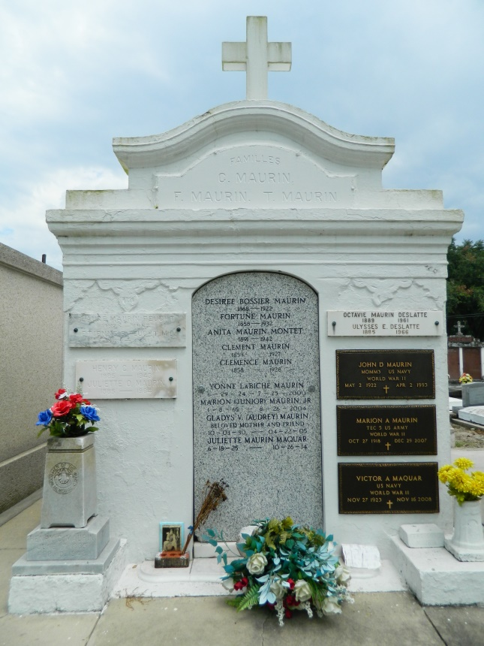 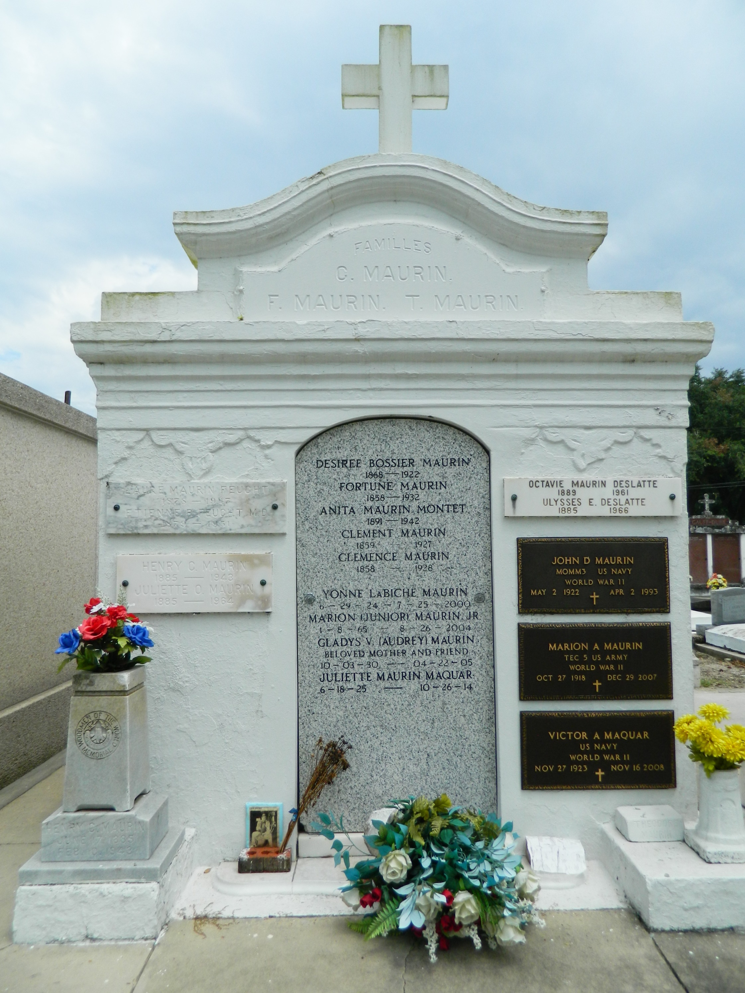

Marion (Junior) Maurin, Jr., on Thursday August 26, 2004 at 11:15 a.m. Beloved son of Marion (Poose) Maurin and the late Yvonne LaBiche Maurin. Also survived by aunts and cousins. Age 39, a native and resident of Laplace.   
 Relatives and friends of the family are invited to attend the services. Visitation at Millet-Guidry Funeral Home, 2806 West Airline Highway, Laplace on Sunday, August 29, 2004 from 5:00 p.m. until 9:00 p.m. and on Monday from 8:00 a.m. until 9:45 a.m. followed by religious services at Joan of Arc Catholic Church, Laplace at 10:00 a.m. Burial in St. Peter Cemetery, Reserve. In lieu of flowers Masses preferred.

**Times-Picayune, The (New Orleans, LA) — Saturday, August 28, 2004**

*****

LAPLACE - Marion "Junior" Maurin Jr., 39, a native and resident of LaPlace, died Aug. 26. He was the son of Marion "Poose" Maurin, and the late Yvonne LaBiche Maurin.   
 Services were Aug. 29 at St. Joan of Arc Catholic Church, LaPlace, with interment at St. Peter Cemetery, Reserve.

**L'Observateur (La Place, LA) — Wednesday, September 1, 2004**

**Both contributed by Jane Edson**