Yvonne (LaBiche) Maurin

June 29, 1924 – July 25, 2000

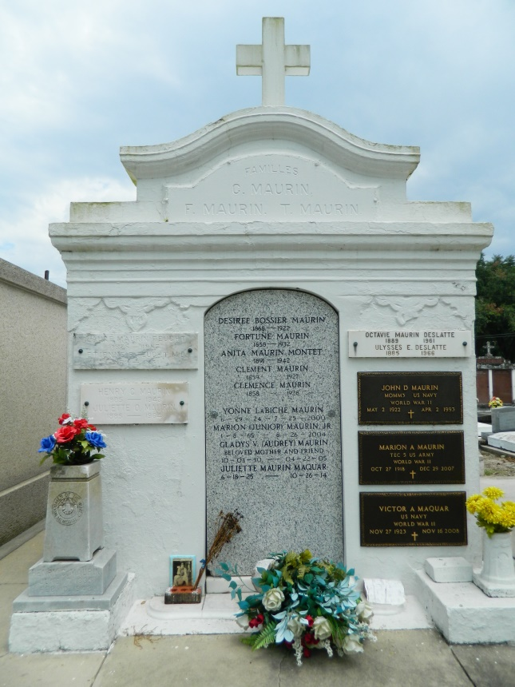 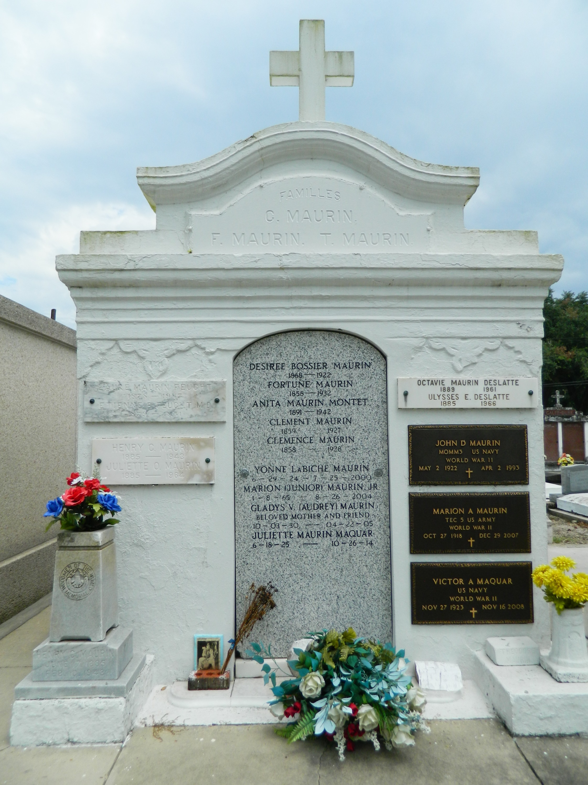

Yvonne LaBiche Maurin, 76, a native of White Castle and resident of LaPlace for 49 years, died July 25. She was the wife of Marion"Poose" Maurin and mother of Marion "Junior" Maurin Jr.   
  
She was also the daughter of the late Alfred and Annette Ory LaBiche and sister of Marielee Bass, Joycelyn Schowalter and the late Merle LaBiche and Genevieve Clarke.   
  
Services were July 27 at St. Joan of Arc Catholic Church, LaPlace, with interment at St. Peter Cemetery, Reserve.

**L'Observateur (La Place, LA) - Saturday, July 29, 2000**

**Contributed by Jane Edson**