Willie S. John Maus Jr.

August 1, 1947 – March 9, 2012

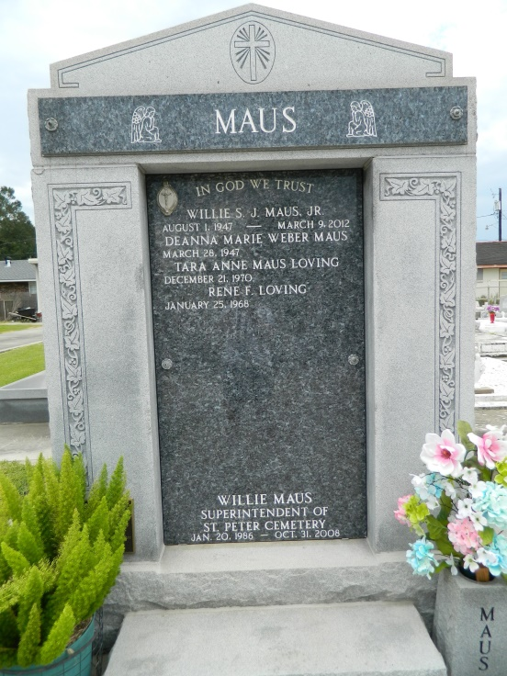 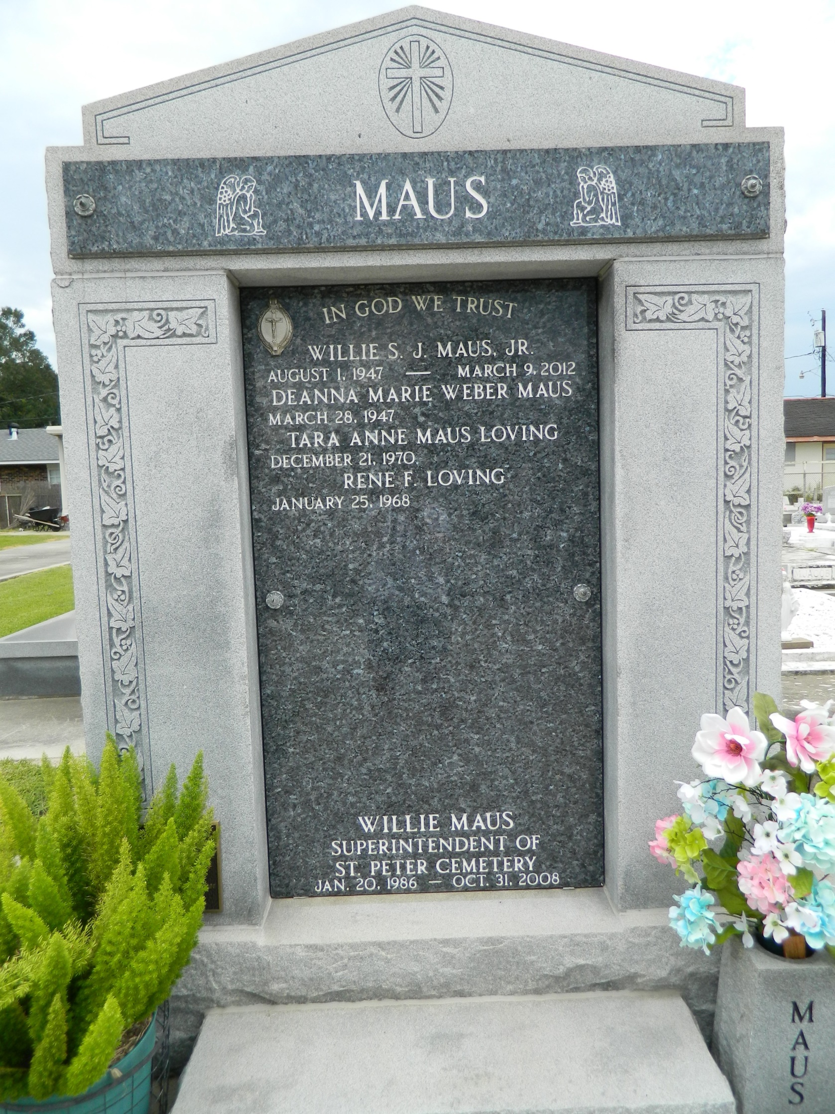

Willie S. John Maus Jr., 64, entered peacefully into eternal rest at his home on Friday, March 9, 2012, at 10:57 p.m., surrounded by his family.   
 He was the beloved husband of Deanna Weber Maus for 44 years and adored father of Bill Maus (Kasey) and Tara Loving (Rene). He was also the proud "Paw" of Jordan, Logan and Camryn, loving and expectant grandfather of baby Maus, son of the late Nelda Dupre and Willie S. Maus Sr., brother of Marian Loupe (Don) and brother-in-Law of the late Perrin Weber (Catherine), the late Margaret Catoire Laurent (the late Calvin Catoire and Kenneth Laurent), Merlene St. Pierre (Frank), the late Tojo Weber (Beverly) and the late Glynn Weber (Carolyn). He is also survived by many cherished nieces, nephews, friends and high school classmates.   
 He was a native and resident of Reserve and a graduate of Leon Godchaux High School and Nicholls State University. He was employed most recently as the superintendent of St. Peter Cemetery and previously by Isidore Newman High School, Godchaux Henderson Sugar Refinery and Graugnard Farms. His most cherished moments were spent with his loving family, who surrounded him with love and laughter throughout his life and in his final days as he lost his battle with cancer.   
 A funeral Mass celebrating his life was held at St. Peter Catholic Church in Reserve on Monday, March 12, 2012. Burial followed in St. Peter Cemetery in Reserve.

**L'Observateur (La Place, LA) — Wednesday, March 14, 2012**

**Contributed by Jane Edson**