Marguerite (Perret) McMurry

1906 – March 7, 2002

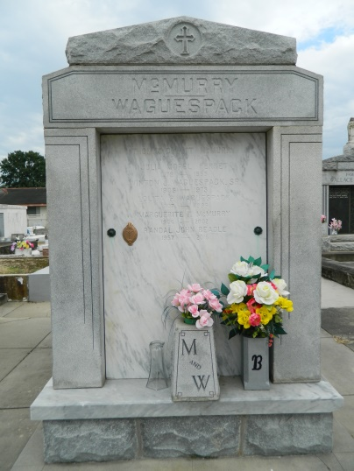 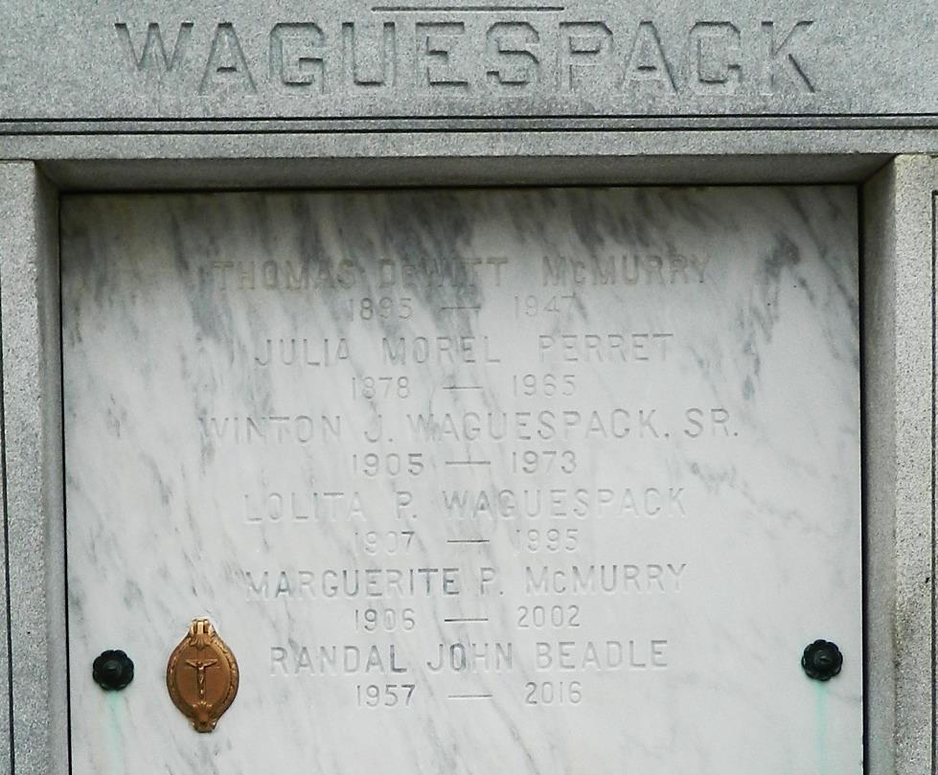

NORCO - Marguerite Perret McMurry, 96, a native of Reserve and resident of Norco, died March 7. She was the wife of the late Thomas McMurry and mother of Thomas, Courtney and Eula McMurry, and the late Lois Kaiser.   
  
She was the sister of the late Jeanne Starr, Lolita Waguespack and Henry Perret.   
  
She is also survived by 11 grandchildren and 15 great-grandchildren.   
  
Services were March 12 at Sacred Heart of Jesus Catholic Church, Norco, with interment at St. Peter Mausoleum, Reserve.

**L'Observateur (La Place, LA) - Thursday, March 14, 2002**

**Contributed by Jane Edson**