Thelma (Landry) Melancon

December 2, 1908 – July 15, 2002

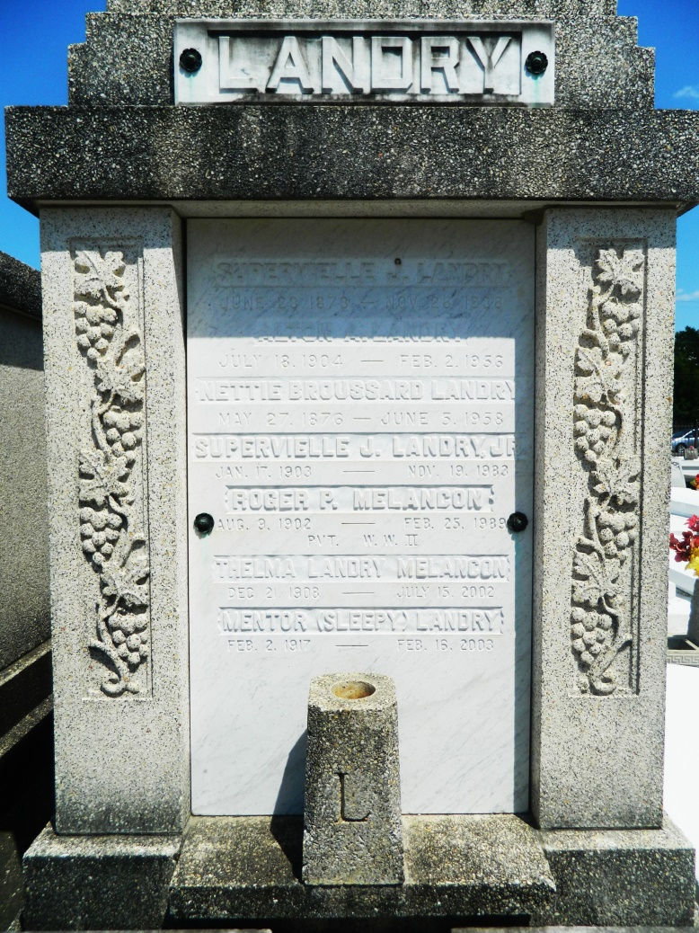

LAPLACE - Thelma "Telmo" Landry Melancon, 93, a native of Garyville and resident of LaPlace for 85 years, died July 15. She was the wife of the late Roger Melancon.  
  
She was the daughter of the late Superville and Nettie Broussard Landry and sister of Theresa Brignac, Edna Rausch, Mentor "Sleepy" Landry and the late Julie Payne, Alton and Superville Landry Jr.  
  
Services were July 18 at St. Joan of Arc Catholic Church, LaPlace, with interment at St. Peter Cemetery, Reserve.

L'Observateur (La Place, LA) - Friday, August 2, 2002

Contributed by Jane Edson