Camilla (Vutera) Milioto

1921 – January 28, 2017

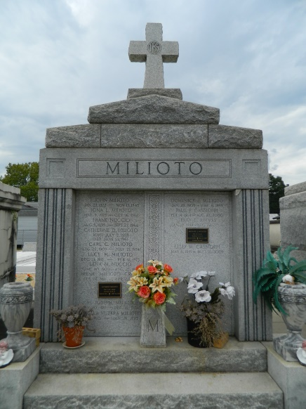 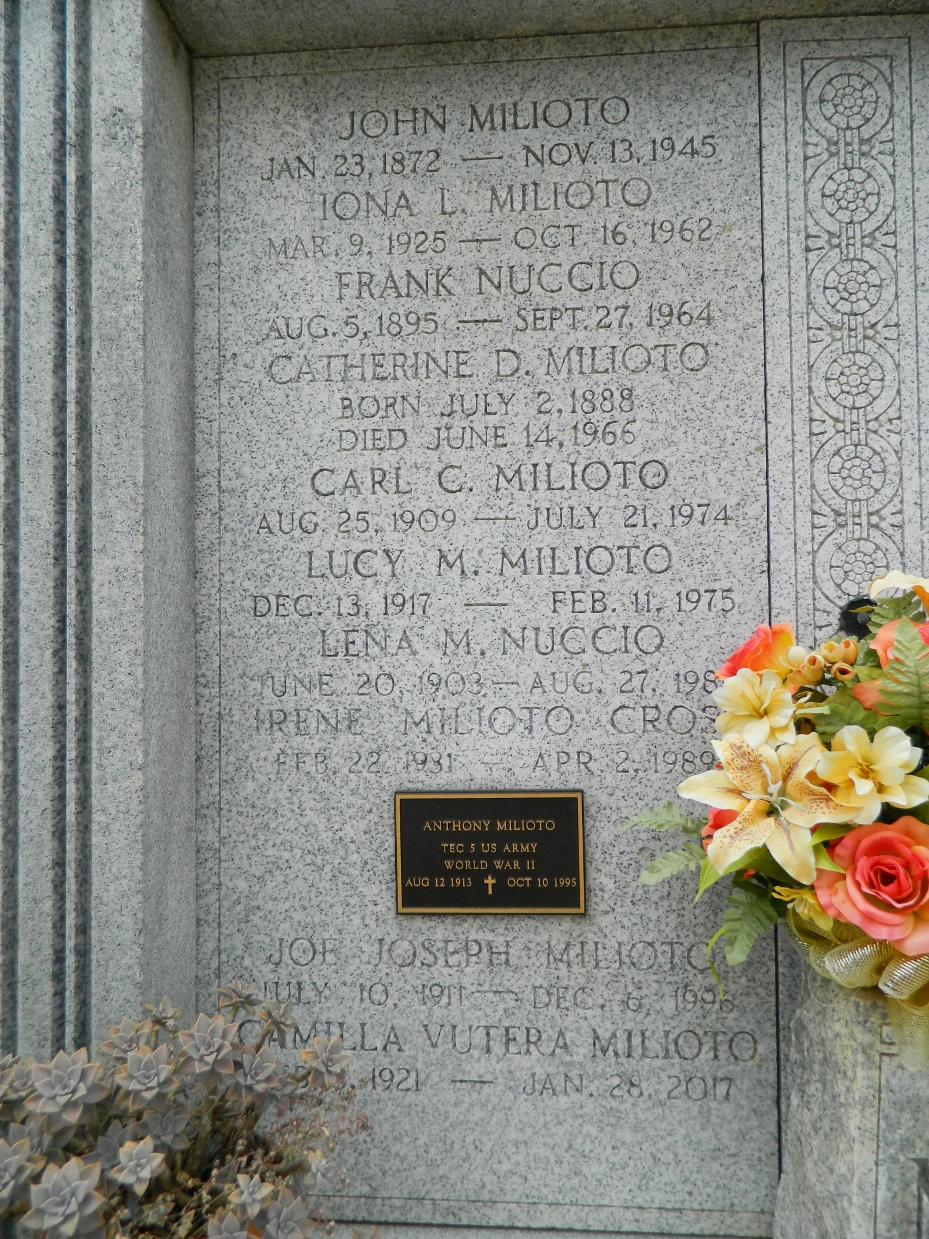

Camilla Vutera Milioto passed away on Saturday, January 28, 2017. She was 95, a native of Hammond, LA and a resident of LaPlace, LA. Beloved wife of the late Dominick J. Milioto. Mother of Catherine M. Hartman (Raymond), Ann M. Reeves, Rosemary Minnie Correia (Edmund) and Joan M. Milioto. Daughter of the late Antonina Pellichino and Matteo Vutera. Sister of Betsy V. Arcuri, Anthony Buddy Vutera, Joe Vutera and the late Louis Vutera, Sam Vutera, and Josie V. Faldetta. Also survived by 4 grandchildren, 8 great-grandchildren, nieces, nephews and sisters-in-law, Gloria, Phyllis, Marie and Virgina Vutera and Lucres Milioto.

Relatives and friends are invited to attend the Funeral Mass at St. Joan of Arc Catholic Church, 529 W 5th Street, LaPlace, LA on Friday, February 3, 2017 at 11:00 a.m. Visitation at the church from 9:30 a.m. until 11:00 a.m. Interment in St. Peter Cemetery. To view or sign the online guest book, please visit [www.milletguidry.com](http://www.milletguidry.com/)

**Times-Picayune, The (New Orleans, LA) - Tuesday, January 31, 2017**

**Contributed by Jane Edson**