Albert Millet

December 7, 1868 – October 26, 1958

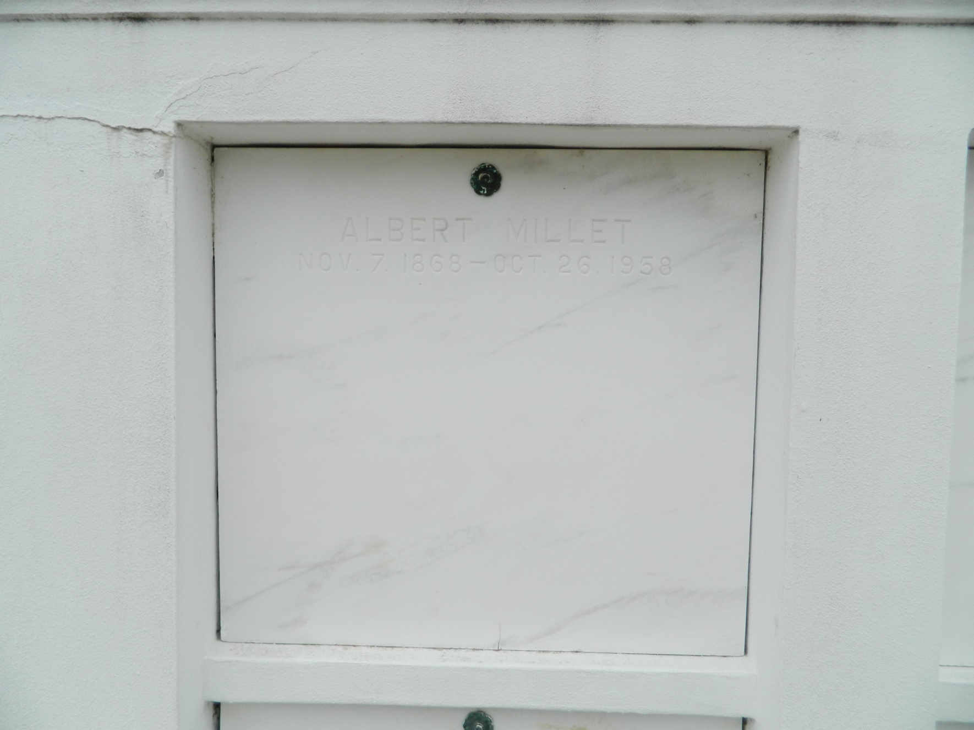

Albert Millet died at the family residence in Reserve, Louisiana, on Sunday 26 Oct 1958 at 5:25 pm at age 89 years, 11 months and 12 days. He was the husband of the late Honorine Perilloux and the father of Leo A Millet of Ama, Louisiana, Mrs [Bertha] George Ory of Baker, Louisiana, Mrs [Bernadette] Harold J Jacobs of Matthews, Louisiana, Mrs [Gilberta] O J Champagne of Reserve, Mrs [Honorine] Paul L Daniels of Baker, Louisiana, Gerard G Millet of Montgomery, Alabama, Mrs [Elida] Charles W Caillouet of Baker, Mrs [Odette] J M Braddy of Texas City, Texas [Note: She had second marriage to Raymond Sailer of Pueblo, Colorado], Donald J Millet of Lake Charles, Louisiana and Mrs [Lillie Mae] Andrew Cashio of Lions, Louisiana. He was the brother of Mrs Lawrence Montz of Lions. Also survived by 43 grandchildren, 42 great-grandchildren and 2 great-great-grandchildren. Services were Tuesday 28 Oct 1958 at St Peter Church, Reserve, with interment in St Peter Cemetery, Reserve.  
*From Obituary, The Times-Picayune, 27 Oct 1958*

*Contributed by Dwayne Montz*