Edward Felix ‘Ted” Millet, Jr.

January 9, 1914 – December 2, 2005

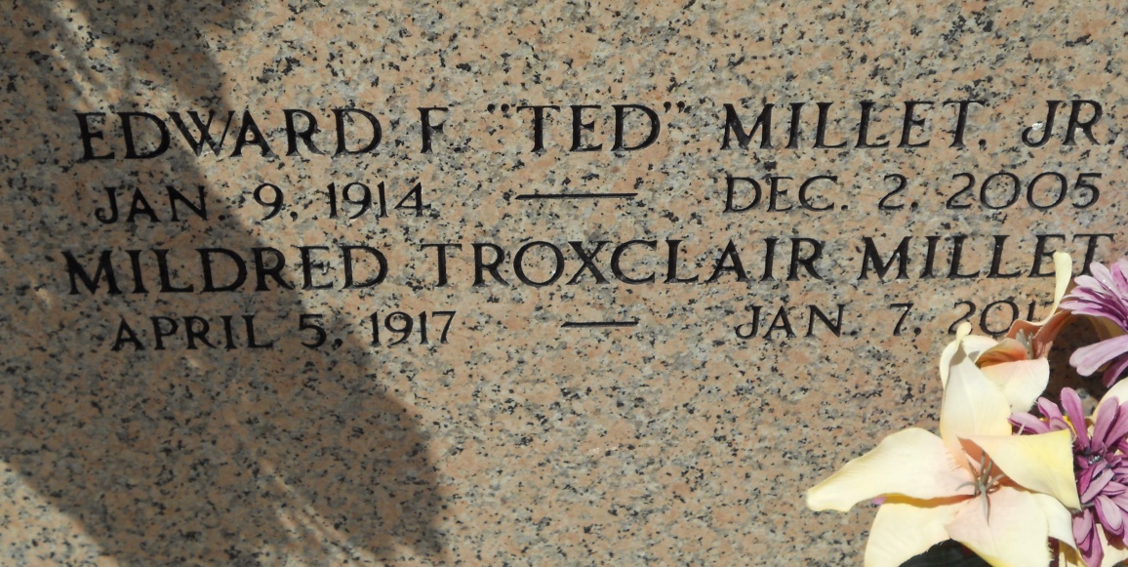

Photo by Team TLo

Edward F. 'Ted' Millet Died Friday, December 2, 2005 At 8:55 P.M. Age 91 Years. A Native Of Lions, La, A Resident Of Mt. Airy, La For Many Years And A Resident Of Grand Point, La For The Past 22 Years.  
 Ted Was A Former Employee Of Godchaux Sugar Refinery, Shell Oil Company, Higgins Industries And A Carpenter With The New Orleans Union On His Retirement. He Was A Member Of The Reserve K.C. Council, The St. Joseph Church Choir, The St. Hubert's Holy Name Society And A Trustee For The St. Hubert's Church.  
 Beloved Husband Of Mildred Troxclair Millet For 70 Years. Loving Father And Father-In-Law Of Peggy Millet And J.L. Robichaux, Jr. Brother Of Helen Lasseigne, Ruby Lee M. Scherer Of Tylertown, Ms And The Late Larry Millet. Proud And Loving Grandfather Of Danny Robichaux, Peggy Jo R. Covington, Joseph 'Joey' Robichaux Iii, Melanie R. Drury And Kathleen R. Loupe. Great-Grandfather Of Jenny, Kelly And Stephanie Covington, Laura And Sophia Robichaux, Conner Loupe, Brandon, Kristal And Lance Drury.  
 Relatives And Friends Of The Family Are Invited To Attend Services. Visitation At St. Joseph Catholic Church, 4130 Rectory St., Paulina, La On Monday, December 5, 2005 From 9:00 A.M. Until 11:00 A.M. Followed By Religious Services At 11:00 A.M. Burial In St. Peter Church Cemetery, Reserve, La. Millet-Guidry Funeral Home In Charge Of Arrangements.  
  
Published in The Times Picayune, New Orleans, Louisiana

December 4, 2005