Elson E. Millet

June 21, 1925 – December 15, 2009

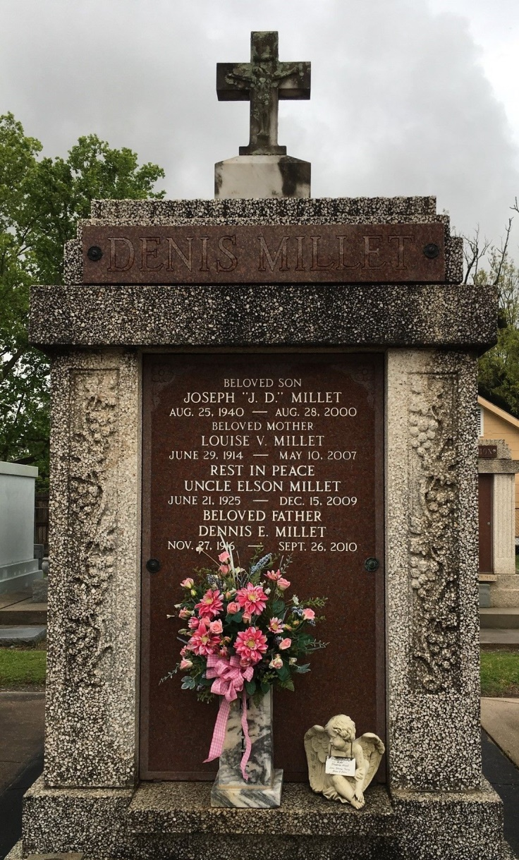

Photo by Team T Lo

Elson (Biff) Millet passed away on Tuesday, December 15, 2009 at The Southeast La. War Veterans Home, Reserve, La. Beloved son of the late Samuel and Corrine Montz Millet. Brother of Dennis and Sammy Millet, Velma Jacob, Lucille Barthel and the late Earl (Mac), Irving, Raymond and Norman Millet and Edna Miano. Sadly missed by nephew Clarence Millet and niece Linda Miano. Also survived by other nieces and nephews. Friend of Beatrice Brock. Age 84. A native of Lions, La. and a resident of LaPlace, La.  
  
Relatives and friends are invited to attend services. Visitation at St. Peter Catholic Church, Reserve, La. on Saturday, December 19, 2009 from 8:30 am to 10:00 am. Followed by a Mass at 10:00 am. Burial in St. Peter Cemetery.  
  
Arrangements by Millet-Guidry Funeral Home, LaPlace, La.

Times-Picayune, The (New Orleans, LA) - Friday, December 18, 2009

Contributed by Jane Edson