Marie Honorine (Perilloux) Millet

August 5, 1871 – August 15, 1958

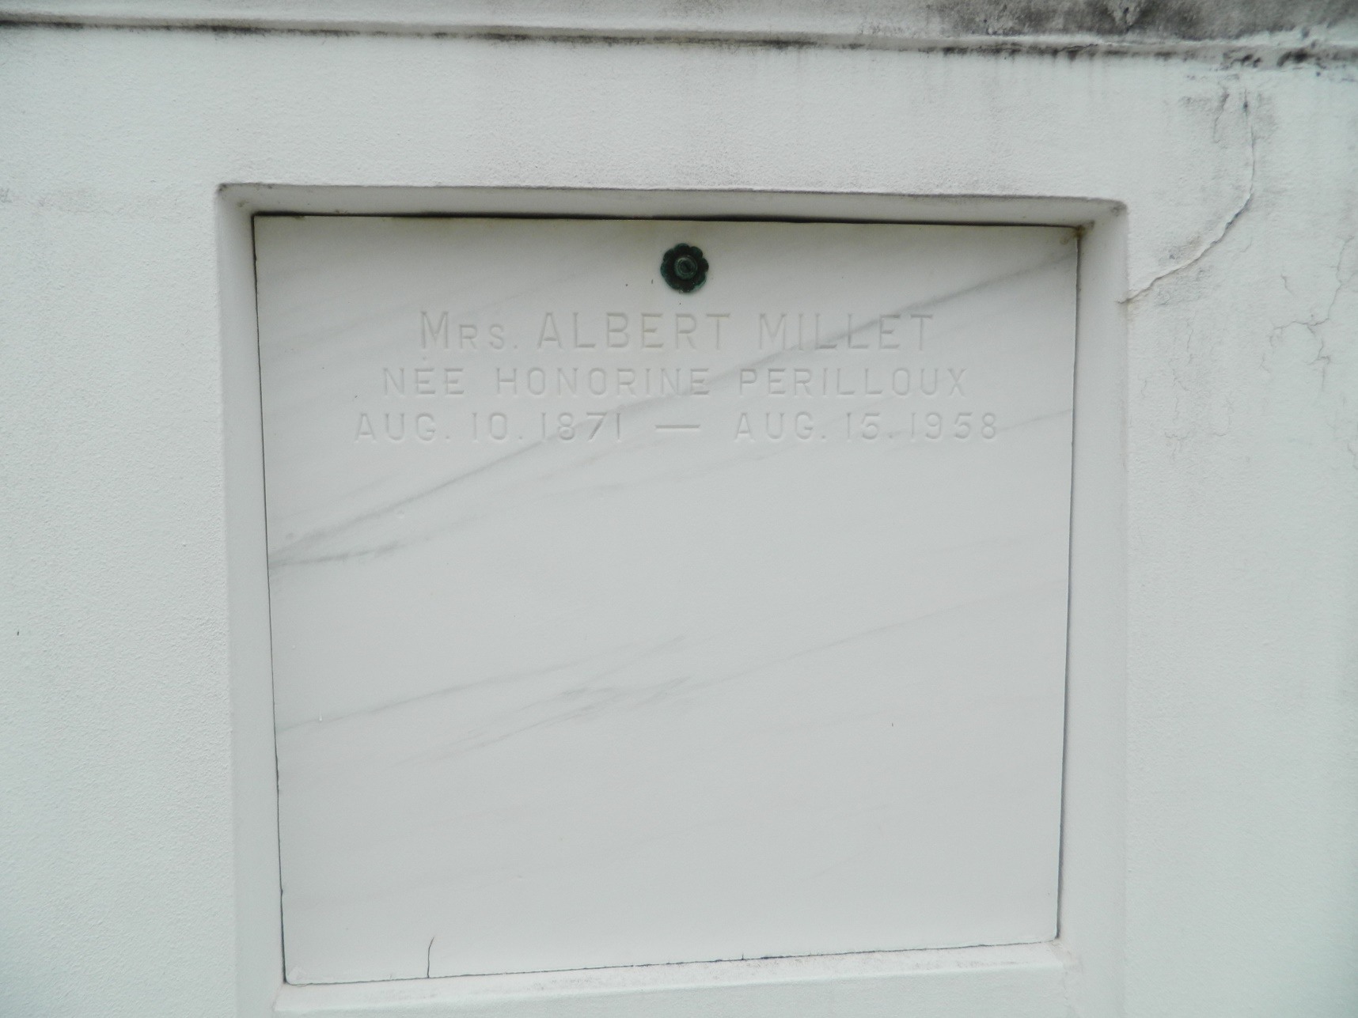

Honorine Perilloux Millet died at the residence in Lions, Louisiana, on Friday 15 Aug 1958 at age 87 years and 5 days. She was a native and resident of Lions and the wife of Albert Millet. She was the mother of Leo A. Millet of Ama, Louisiana, and New Orleans, Mrs. George E. Ory of Baker, Louisiana, Mrs. H. J. Jacobs of Matthews, Louisiana, Mrs. Oneil J. Champagne of Reserve, Louisiana, Mrs. Paul L. Daniels of Baker, Gerard G. Millet of Montgomery, Alabama, Mrs. C. W. Caillouet of Baker, Mrs. J. M. Braddy of Texas City, Texas, Donald J. Millet of Lake Charles, Louisiana, Mrs. A. B. Cashio of Lions, and the late Edward F. Millet. Also survived by 43 grandchildren, 42 great-grandchildren and 2 great-great grandchildren. Services were Saturday 16 Aug 1958 at St Peter Church, Reserve, with interment in St Peter Cemetery, Reserve.

*From Obituary, The Times-Picayune, 16 Aug 1958*

*Contributed by Dwayne Montz*