Irving Antoine Millet

July 30, 1911 – April 15, 2005

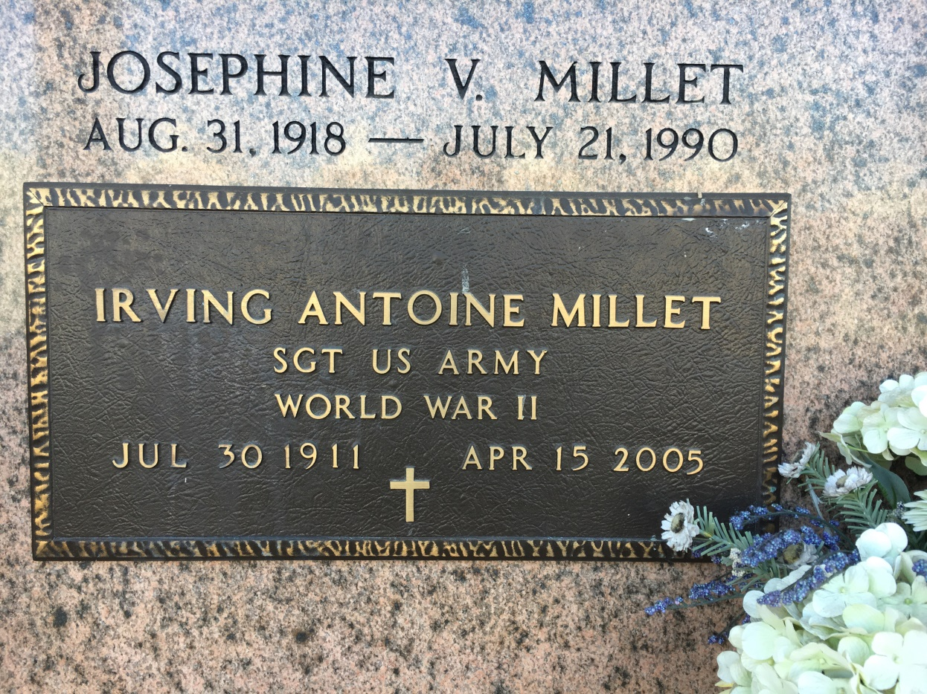

Photo by Team T Lo

Irving A (Snipe) Millet died on Friday 15 Apr 2005 at 10:10 a.m. He was the husband of the late Josephine Vicknair Millet and father of Madeleine Clement, Trudy Delaneuville, Alice Madere, Penny and Rhonda Duhe and the late Irving (Buster) Millet, Jr. He was the son of the late Samuel and Corinne Montz Millet and the brother of Denis, Elson, Earl (Mac) and Sammy Millet Jr, Velma Jacob, Lucille Barthel and the late Raymond and Norman Millet and Edna Miano. Also survived by 16 grandchildren and 11 great grandchildren. Age 93, a native and resident of Reserve, LA. Relatives and friends of the family are invited to attend the funeral services at Millet Guidry Funeral Home, 2806 West Airline Hwy, Laplace, on Monday 17 Apr 2005 followed by religious services at St Peter Catholic Church, Reserve. Burial in St Peter Cemetery, Reserve.

From Obituary, The Times-Picayune, 16 Apr 2005

Contributed by Dwayne Montz