Larry P. Millet

Abt. 1918 – December 27, 2004

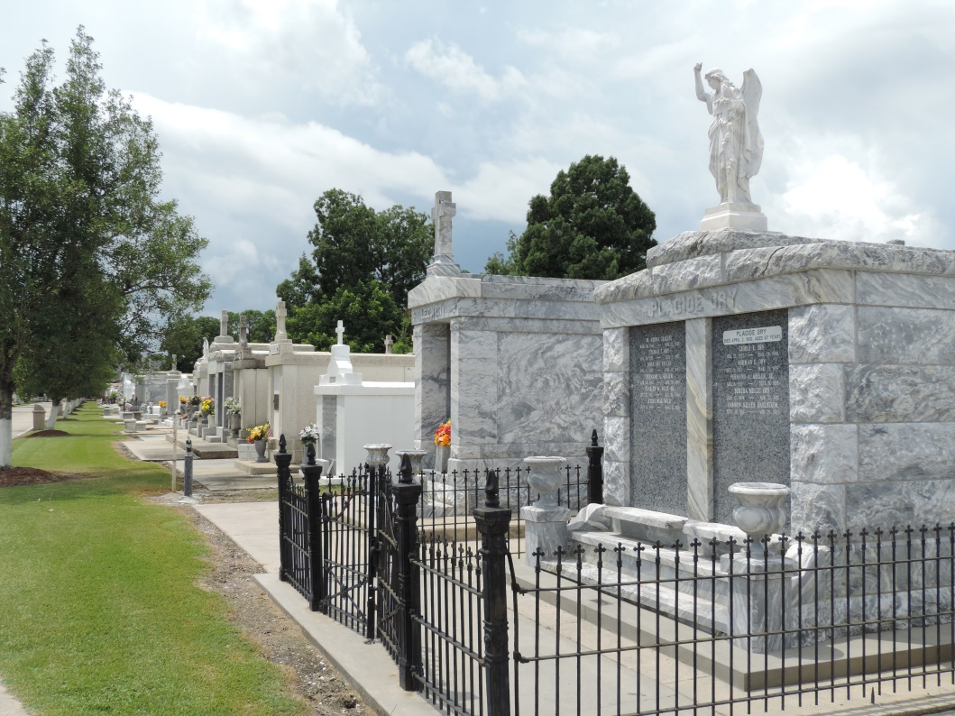

MILLET, LARRY P. died Monday, Dec. 27, 2004, at 12:45 p.m. He was the beloved husband of Emma Pourciau Millet and by first marriage the late Dorothy Madere Millet, father of Lillian Carter, stepfather of Alma Morroy and A.J. Pourciau Jr., grandfather of Maria Bleakley, Larry Joe Scioneaux and Blake Scioneaux, stepgrandfather of Chris, Davis and John Pourciau and Mike, John and Christina Morrey; brother of Ted Millet, Ruby Lee Scherer and Helen Lasseigne.

He was 86, a native of Lions, former resident of Reserve and a resident of Baton Rouge for 13 years.

Relatives and friends of the family and members of VFW are invited to attend the service. Visitation at Millet-Guidry Funeral Home, 2806 Airline Highway, LaPlace, Thursday, Dec. 30, from 10 a.m. until religious service at noon. Burial in St. Peter Cemetery, Reserve. He was a member of St. Isidore Catholic Church.

Published in TheAdvocate.com on Dec. 31, 2004

Contributed by Jane Edson