Lyle John Russell Millet

March 29, 1928 – April 9, 2015

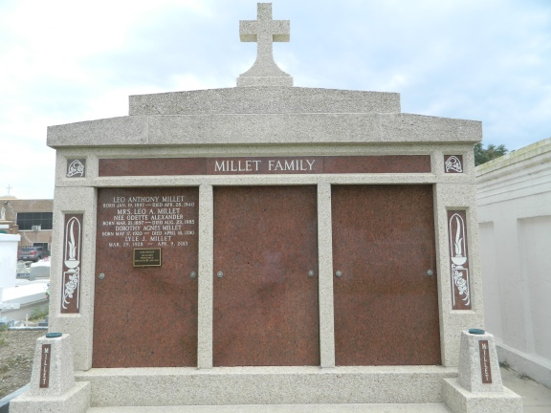 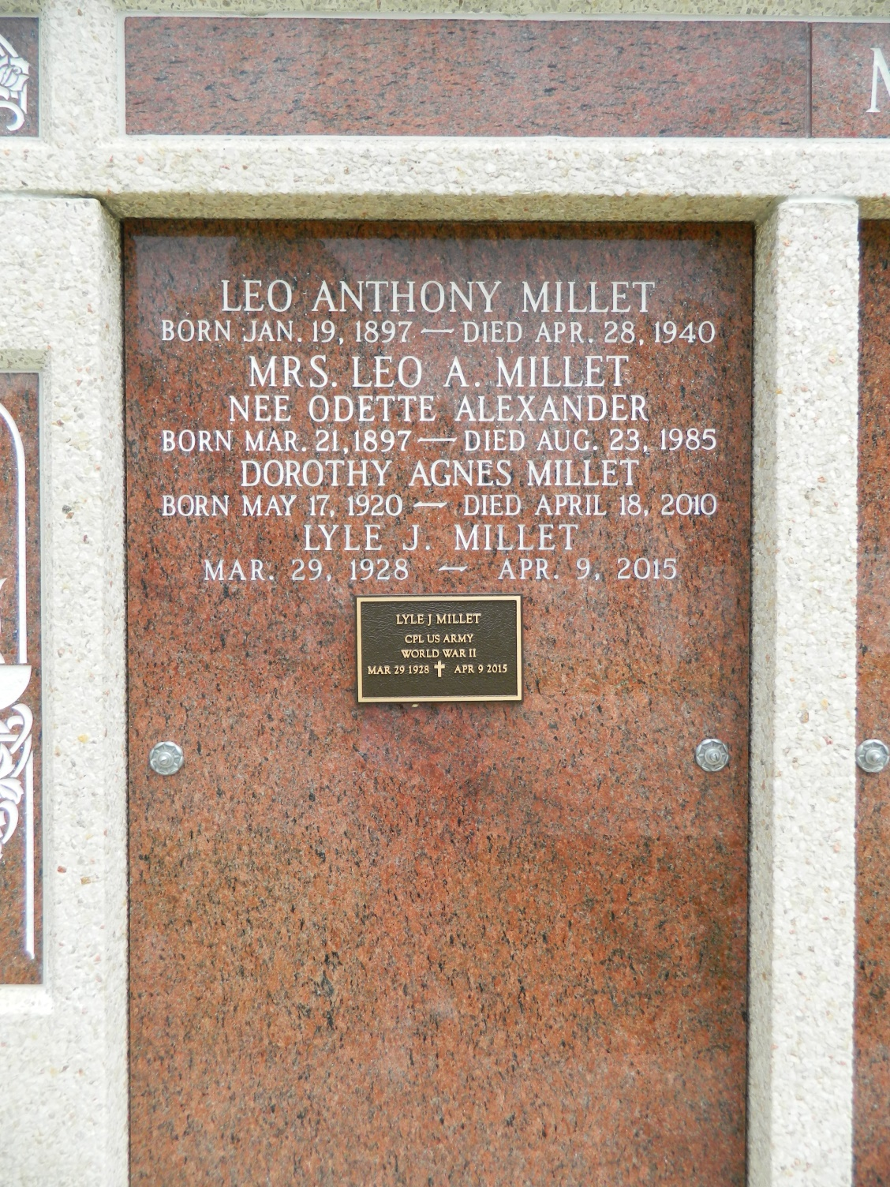

Lyle John Russell Millet, 87, passed away on April 9, 2015.   
 He was a lifelong resident of Hope Plantation in Garyville, where he enjoyed hosting many family gatherings.  He was a veteran of the Korean War and retired from Shell Chemical company in 1985 after 30 years of service. He was also a longtime member of the St. John Parish School Board.   
 He was preceded in death by parents Leo Anthony Millet and Odette Alexander Millet and siblings Leo Alexander Millet, Dorothy Agnes Millet, Roland Anthony Millet, Jacqueline Millet Kern and Minnette Millet Montegut.   
 Survivors include brothers David Wesley Millet of Reserve and Jean Ovide Millet of Covington and his sisters Barbara Millet Millet of LaPlace, Carol Millet Vicknair of Madisonville, and Gwen Millet Lemonier of New Orleans.  He is also survived by 28 nieces and nephews.   
 Relatives and friends of the family are invited to attend a Funeral Mass at 11 a.m. Monday, April 13 at St. Hubert's Catholic Church in Garyville.  Interment will follow at the family tomb in St. Peter's Cemetery in Reserve.  Visitation will take place from 9 until 11 a.m. at St. Hubert's Catholic Church.   
 Arrangements are by Millet-Guidry Funeral Home. To view or sign the online guest book visit [milletguidry.com](http://milletguidry.com/).

**L'Observateur (La Place, LA) - Friday, April 10, 2015**

**Contributed by Jane Edson**