Maxine (Aucoin) Millet

October 29, 1926 – January 10, 2014

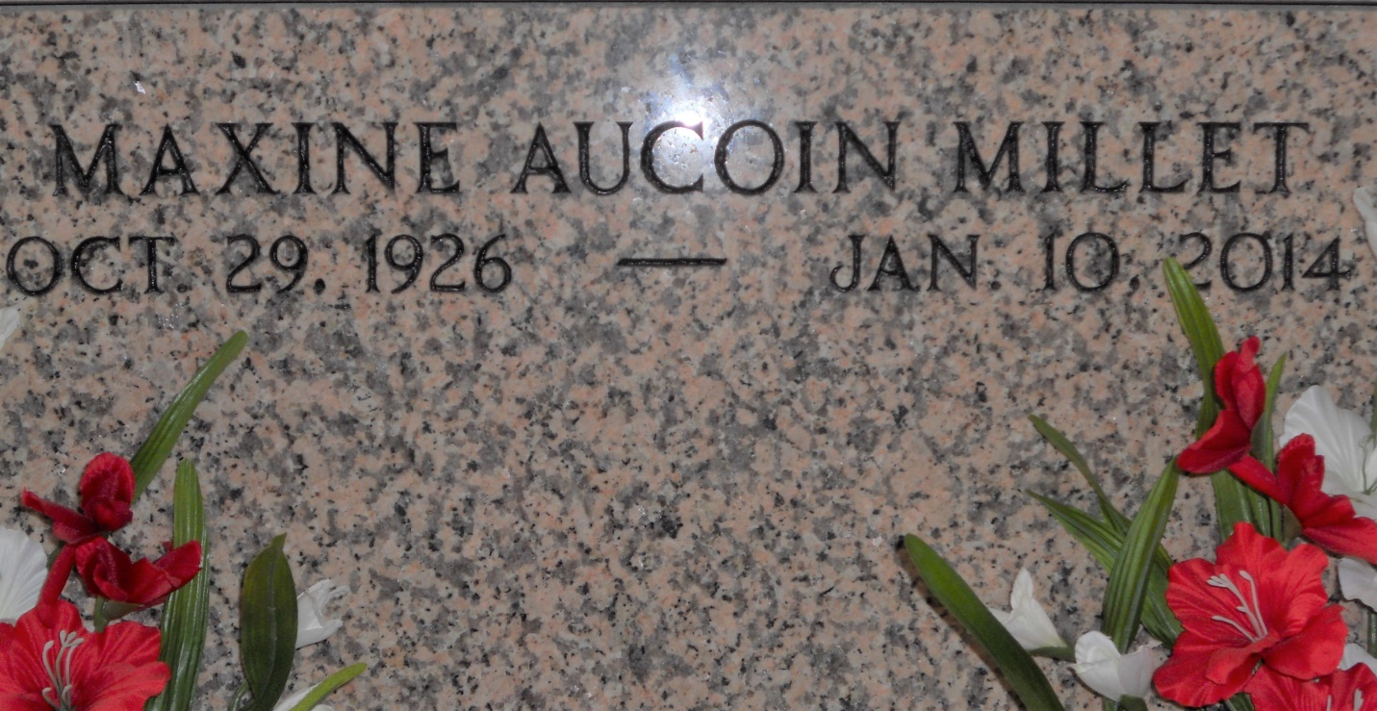

Photo by Team T Lo

Maxine Aucoin Millet, 87, died on Friday, Jan. 10, 2014.

She was the beloved wife of Elmore J. Millet and mother of Brent Millet, Georganne Detillier (Rg), Terry Millet (Patsy), Jay Millet (Laurie) and Sue Miller (Rick). She is also survived by 12 grandchildren and 16 great-grandchildren.

She was the daughter of the late Charles and Rowena Templet Aucoin and sister of Lionel (Vera) and Charles Aucoin (Gloria).

She was a native of Plattenville, La., and resident of LaPlace.

Visitation and services were held at St. Joan of Arc Catholic Church in LaPlace on Monday, Jan. 13, 2014, followed by burial in St. Peter Cemetery in Reserve.

L’Observateur, LaPlace, LA; Tuesday, January 14, 2014