Roland Anthony Millet

October 16, 1921 – November 12, 2012

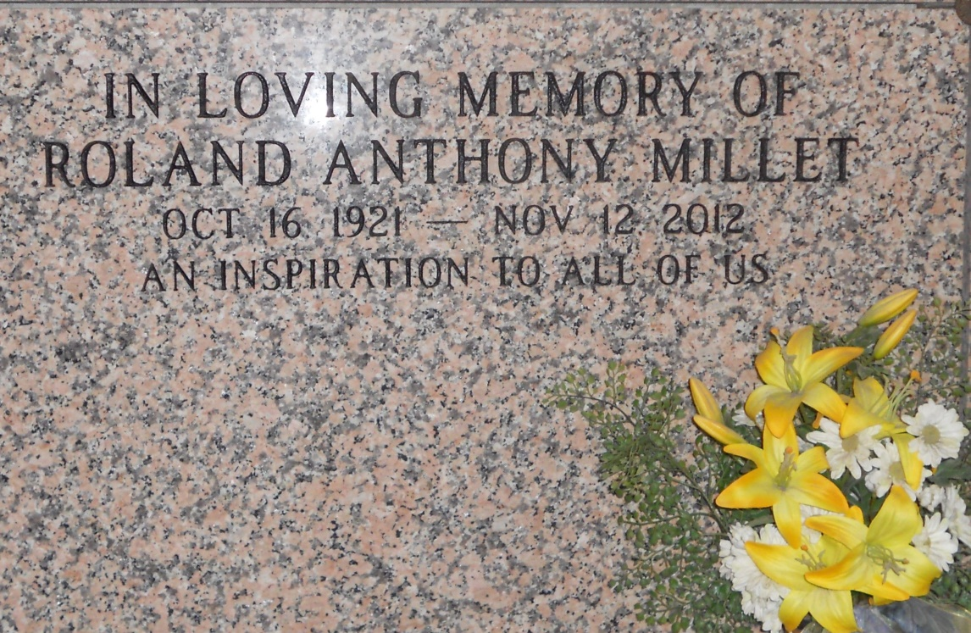

Photo by Team T Lo

Roland A. Millet, 91, passed away Monday, Nov. 12, 2012.

He was the beloved husband of Melba Simon Millet and father of Byron Millet (Drema), Susan Gomila (Bill), Jane Roussel (Kevin) and Alison Ariail (John). He is also survived by 11 grandchildren and 12 great-grandchildren.

He was the son of the late Leo and Odette Alexander Millet, brother of Barbara Millet, Carol Vicknair, Gwen Lemonier and Lyle, David and Jean Millet and the late Minnette Montegut, Jacqueline Kern and Leo and Dorothy Millet. He is also survived by nieces and nephews.

He retired from Shell Oil. He was a native and resident of Garyville.

Visitation and services were held at at St. Peter Catholic Church in Reserve on Friday, Nov. 16, 2012. Burial followed in St. Peter Cemetery in Reserve. Arrangements were by Millet-Guidry Funeral Home of LaPlace.

L’Observateur, LaPlace, LA; Friday, November 16, 2012