Louise R Monica Sr.

August 11, 1931 – February 23, 2006

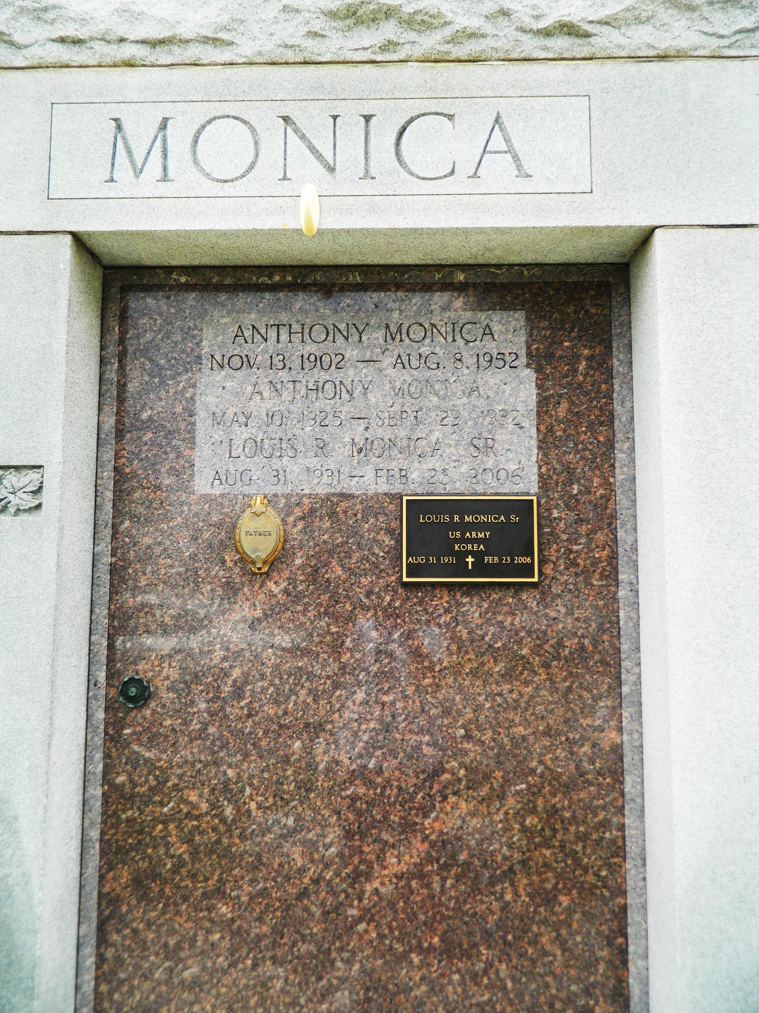

Louis R. (L.R.) Monica, Sr., on Thursday, February 23, 2006, at 7:00 P.M. Beloved husband of Joycelyn Smith Monica. Devoted father and father-in-law of Tony and Cindy Monica, Kathleen Monica and Paul Simon, Deborah Monica and David Naquin, Joycelyn Monica and Randy Himel and Raymond and Linda Monica. Grandfather of Katie Kolwe, Maria Monica Cauble, Jessica Himel, Lauren and Allison Naquin and Ray, Lindsey and Austin Monica. Son of the late Anthony Monica and Agnes Hargis Monica Miano. Step-son of Victor Miano. Brother and brother-in-law of Levi T. and Betty Monica. Retired from Texaco/Motiva, Convent, LA, after 27 years. Age 74. A native and resident Garyville, LA.   
  
Relatives and Friends of the Family are invited to attend services. Visitation at St. Hubert Catholic Church, Garyville, LA, on Monday, February 27, 2006, from 9 A.M. to 1 P.M. Followed by Religious Services at the church at 1:00 P.M. Burial in St. Peter's Cemetery, Reserve, LA. Arrangements by Millet-Guidry Funeral Home, Laplace, LA

**Times-Picayune, The (New Orleans, LA) - Sunday, February 26, 2006**

**Contributed by Jane Edson**