Nemours Albert Montz

October 25, 1918 – February 10, 2015

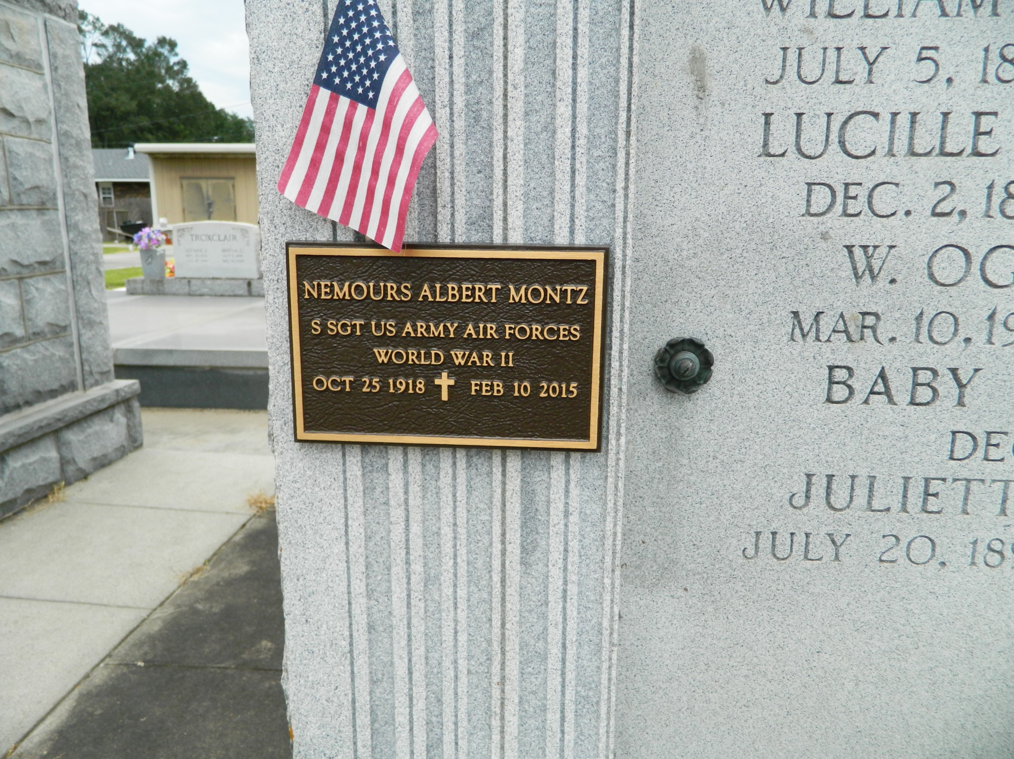

Nemours 'Nem' A. Montz, a WWII Veteran, passed away on Tuesday, February 10, 2015. He was 96, a native of Reserve, LA and a resident of LaPlace. Beloved husband of Shirley Wilton Montz for 70 years. Father of Wayne 'Scrap' Montz (Carol) and Patty Silva (Craig). Son of the late Aline Perilloux and Armand Montz. Brother of the late Armand Montz, Jr. and Alice Mae Maurin. Grandfather of Steven, Carey, Jill, Todd and Abby. Also survived by 5 great-grandchildren, nieces and nephews.

Nem was an avid LSU Tiger Fan. Relatives and friends are invited to attend the Mass at St. Joan of Arc Catholic Church, 529 W. 5th St., LaPlace on Monday, February 16, 2015, at 12:00 noon. Visitation will begin in church at 9:30 a.m. Interment in St. Peter Cemetery. To view or sign the online guest book, please visit [www.milletguidry.com](http://www.milletguidry.com/)

**Times-Picayune, The (New Orleans, LA) - Friday, February 13, 2015**

**Contributed by Jane Edson**