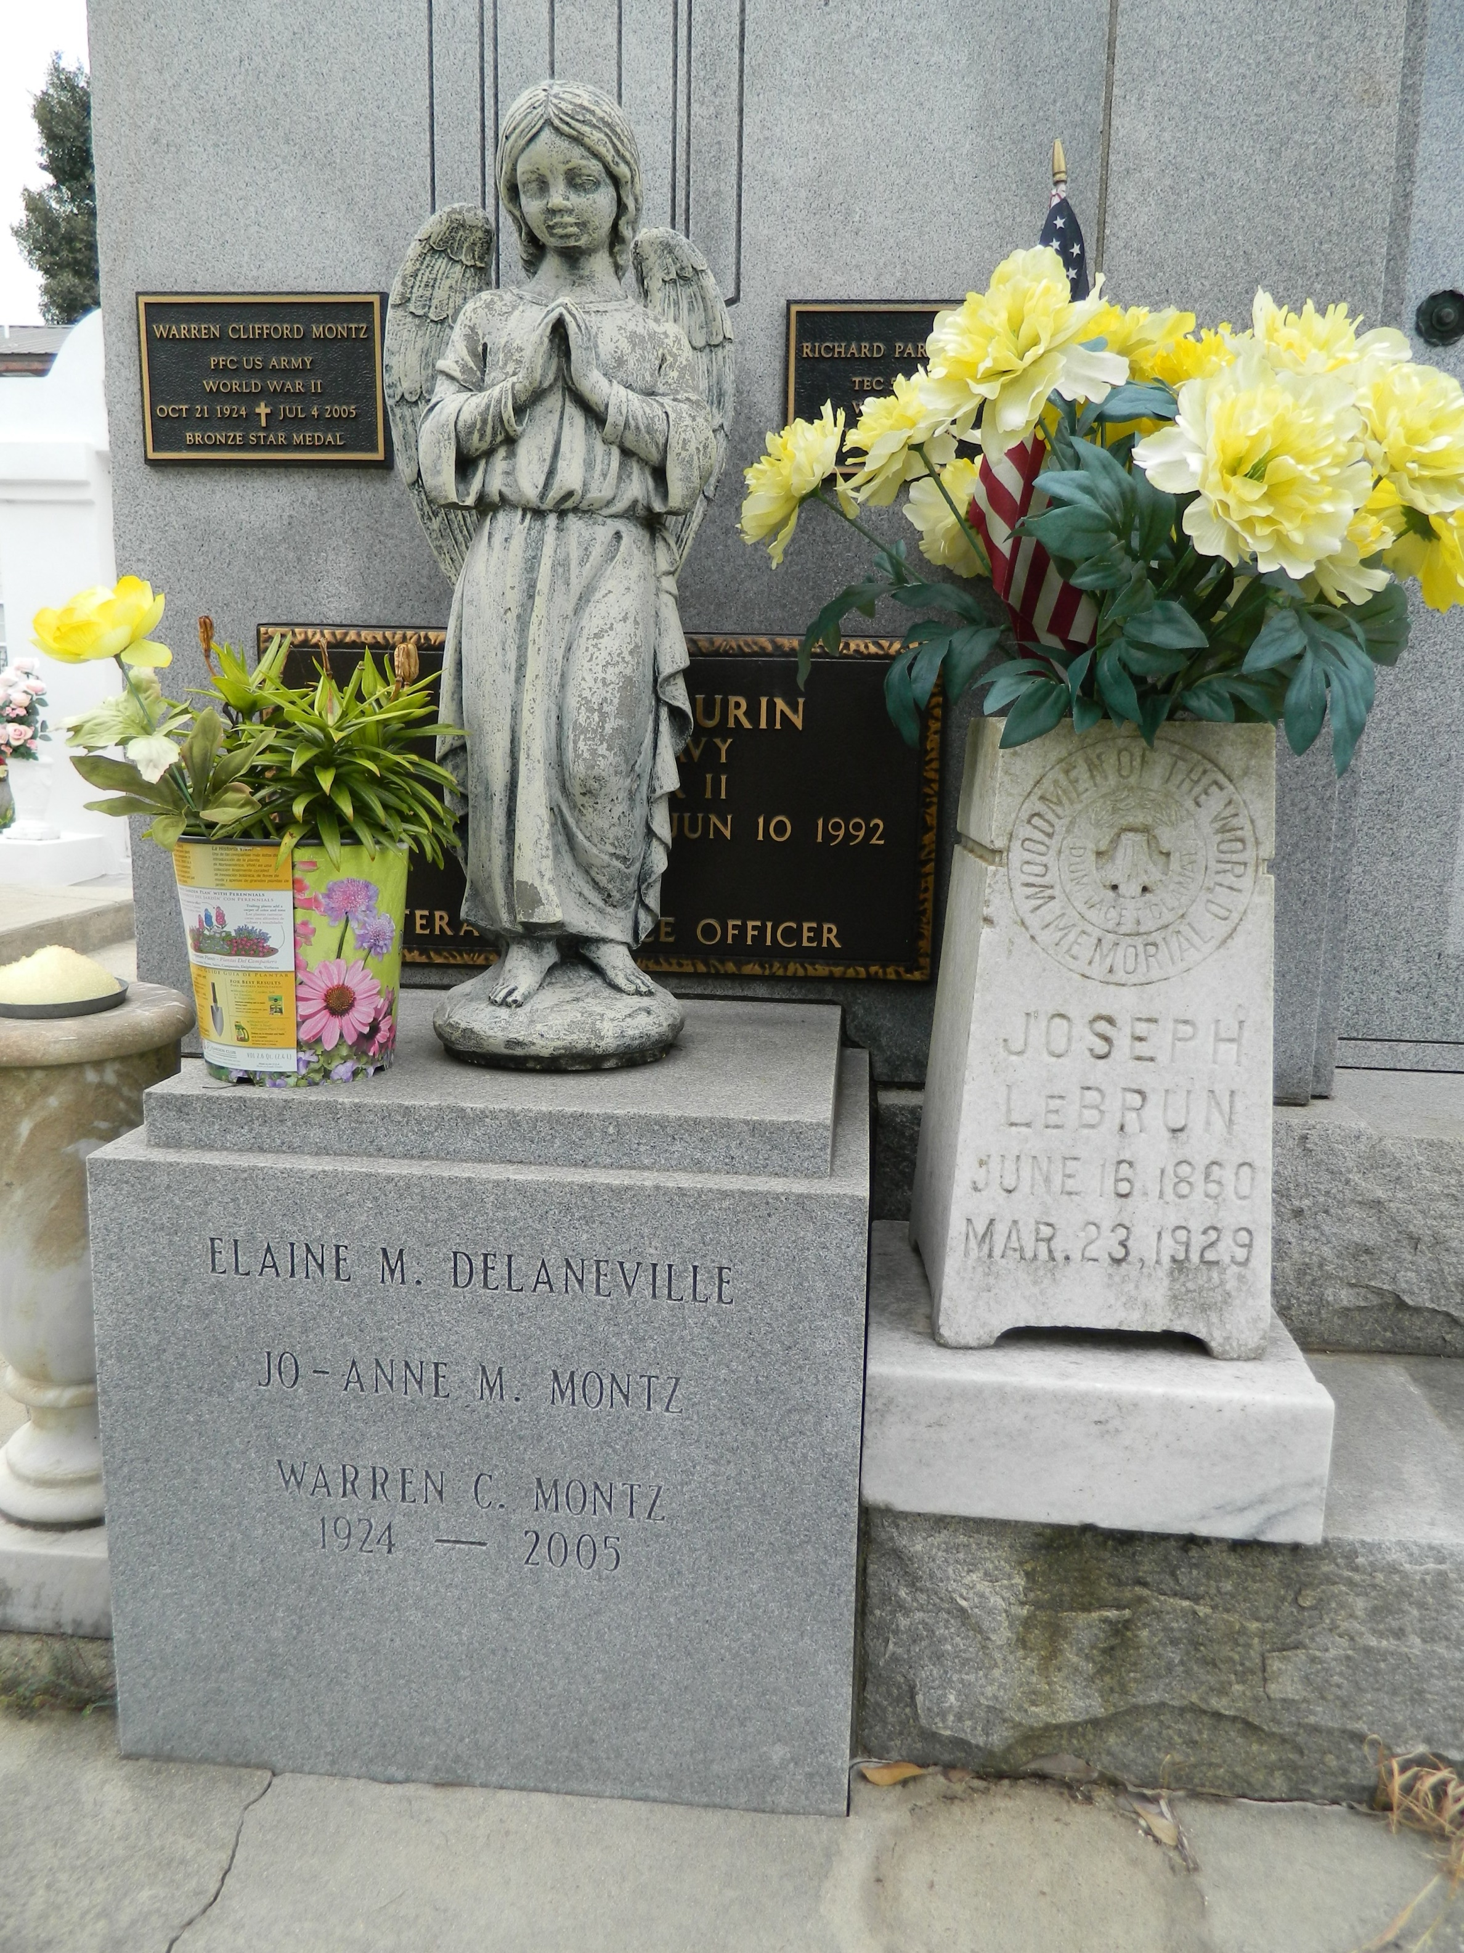

Warren Clifford "Smokey" Montz, retired owner of Montz Insurance Agency, died Monday of complications from Alzheimer's disease at the Louisiana War Veterans Home in Jackson. He was 80.

Mr. Montz was born in New Orleans and lived in Garyville and LaPlace. He attended Leon Godchaux High School and the Southwestern Louisiana Institute. He was a former employee of LaPlace Telephone Co. and the owner of Montz Insurance Agency and Elmwood Travel. Mr. Montz was a member of the LaPlace Volunteer Fire Department, the Knights of Columbus, Veterans of Foreign Wars, American Legion and Boy Scouts of America. He was a private first class in the Army from 1943 to 1946, serving in the Pacific Theater. He received good conduct and Victory medals and a Bronze Star.

Survivors include his wife, Joanne Maurin Montz; two sons, Timothy and Steven Montz; two daughters, April Campbell and Marsha Zettler; a sister, Elizabeth Montz DeRoches; and seven grandchildren.

A Mass will be said Thursday at noon at St. Joan of Arc Catholic Church, 529 W. Fifth St., LaPlace. Visitation will begin at 10 a.m. Burial will be in St. Peter Church Cemetery. Millet-Guidry Funeral Home is in charge of the arrangements.

**Times-Picayune, The (New Orleans, LA) - Wednesday, July 6, 2005**

**Contributed by Jane Edson**